

Mathematics Calculation Policy
Addition
Key Language: | Part, whole, add, more, smaller, bigger, number bonds
Reception
ELG  - Automatically recall (without reference to rhymes, counting or other aides) number bonds up to 5 (including subtraction facts) and some number bonds to 10, including double facts. |  |  | Resources  - Objects for counting  - Number line  - Tens/ fives frames  - Part whole model  - Counters  - Numicon  - Unifix/multilink
Concrete |  | Pictorial |  | Abstract
Finding one more  Children to recognise one more by adding on one to a given amount physically using counting objects.  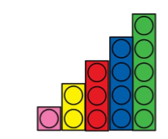  Use five frames to count a given amount and then add on one.  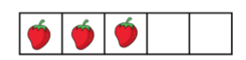 |  | Children to show that they are adding on one more by drawing one more on.  Children to recognise this on a number line.  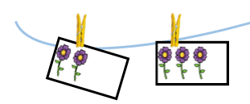  + 1  3  2 |  | Abstract into a number sentence  2 + 1 = 3
Number bonds to 5  Use fingers to show bonds to five.  Three fingers up 2 fingers down  3 and 2 make 5.      Use numicon to build numbers to five. Five is an odd number so will have the additional 1 on its own.  This will help children to recognise the shape of five.  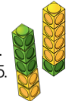  Multilink and unifix to show two parts to make five and then the whole.  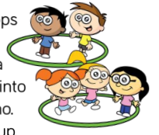  Children to physically arrange themselves into two parts and then discuss the whole.  Remember to include adding 0 and what this means. |  |   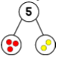  Use a part whole model to show the two parts.  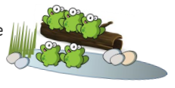  Five frames can be used to show two parts and the whole.  Draw pictures- discuss the two parts and what these come together to make (whole) |  | You can use a calculation frame to support writing of number sentences.  3 + 2 = 5  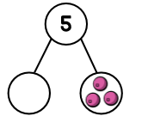  Find the missing part- what do you need to add to 3 to get to five?
   | + |  | =
Addition within 10- combining two amounts    Identify the two group/parts  What is the whole?  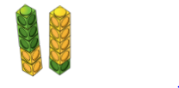  Use multilink to make two parts and then bring them together to represent the whole.  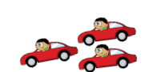   |  | Use of a part whole model to represent the two parts being combined to make the whole  Part and part make the whole  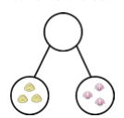  3 and 3 make 6 |  | You can use a calculation frame to support writing of number sentences.  3 + 3 = 6  Find the missing part- what do you need to add to 3 to get to five?  6
   | + |  | =
Number bonds to 10 (tens frames)  Use fingers to represent bonds to ten.  10 fingers up  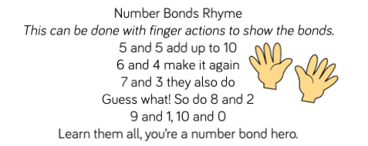  0 fingers down  Use of numicon to build tens frames.  Makes it easy for children to see the two parts and the whole.  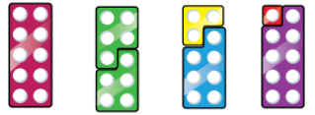 |  | 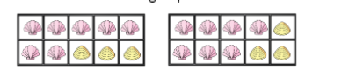  Use of tens frames to draw upon the use of numicon previously. children can start to recognise the shapes within the frames |  | Children to write the number sentence to show their understanding of bonds to ten.
Number bonds to 10 (part whole model)  Use number beads to show the two parts. Children can physically move the beads together to show the whole.  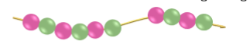  Using bottles to separate 10 into 2 parts.  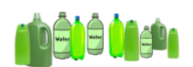 |  | Use the part whole models to separate 10 objects into two parts.    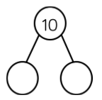 |  | Use of part whole model using numbers not objects  Show part whole models in different rotations  5  5
Adding more  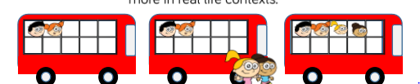  4  Use number tracks to replicate the image given to the children  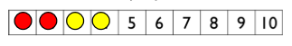 |  | 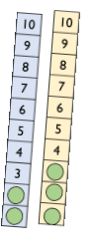  Use number tracks to show counting on between 10. |  | Children to use a number line and make jumps to show that they are adding more.
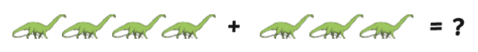
Conceptual variation:
Children to count each dinosuar to find the whole understanding that each time you count a dinosaur you are adding on one more to the number you started with. |  | Children to make the two numbers and recognise the shape of the bonds to 7 (numicon shape) |  | Children could use number tracks to start from 4 and count on three using counters to cover the numbers that they have reached.  (Children could complete this mentally)
   |  |  |  | 5 | 6 | 7

Addition
Key Language: | Sum, total, parts and wholes, plus, add, altogether, more, is equal to, is the same as
Year 1
National curriculum  Pupils should be taught to:  - read, write and interpret mathematical statements involving addition (+), subtraction (–) and equals (=) signs  -represent and use number bonds and related subtraction facts within 20  -add and subtract one-digit and two-digit numbers to 20, including zero  -solve one-step problems that involve addition and subtraction, using concrete objects and pictorial representations, and missing number problems such as 7 = – 9 |  |  | Resources  - Cubes/counters  - Numicon  - Number lines  - Bead strings  - Tens Frames  - part/Whole frames  - Bar model frames
Concrete |  | Pictorial |  | Abstract
Combine two parts to make a whole.  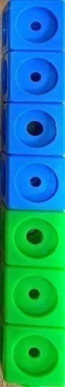  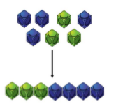  (use other resources too: counters etc)  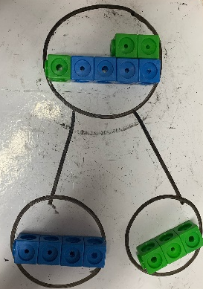 |  | 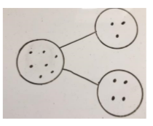  Children to transfer this as a picture using dots or crosses to show the two parts coming together to create the whole. |  | 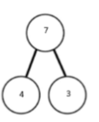  abstract the part whole model by replacing the dots/crosses with numbers.  4 + 3 = 7  7
  3 | 4
Add two numbers within 10 using number bonds  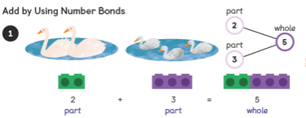  Break apart the group to form bonds to create the whole. Supports understanding of bonds within 10.  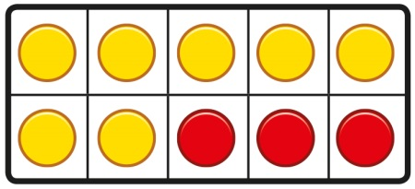 |  | 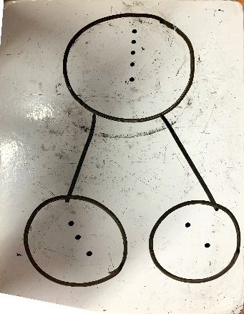  use part whole models and bar models to represent the bonds to ten |  | Abstract the part whole model alongside previous representations to continue to support them in finding number bonds.  2 + 3 = 5
Add by counting on  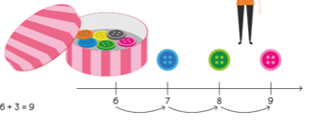 |  | Draw a number track/line starting from the biggest part and count on to find the whole. |  | Children to abstract by using mental strategies to add. Place the larger part in their  head and count on.
  6 | 7 | 8 | 9
  6 | 7 | 8 | 9
Add by making 10.  Children use tens frames to represent the two parts within the number sentence. Then they create a bond to ten and add the additional counters left to the completed 10.  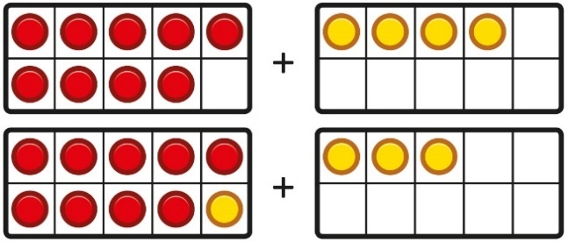 |  |  |  | 9 + 4 = 13  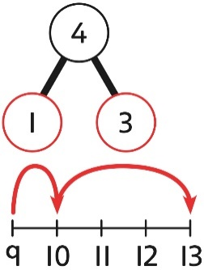  9 + 1 = 10  10 + 3 = 13
Adding ones  Children to think about how 12 can be partitioned to make it easier to add 6 to.  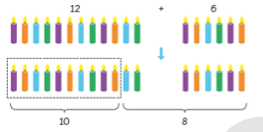 |  | Use tens frames to get the children to see that a teen number is made from a completed ten and ones. Children then add ones to the existing ones already in the tens frame.  10  2 |  | 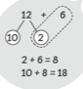  children recognise that a teen number is made from tens and ones and use their understanding of addition within 10 to work more elegantly.
   |  | +1 | +1 | +1
  +1 | +1
Conceptual variation: Find the sum of 7 and 11
 |  | 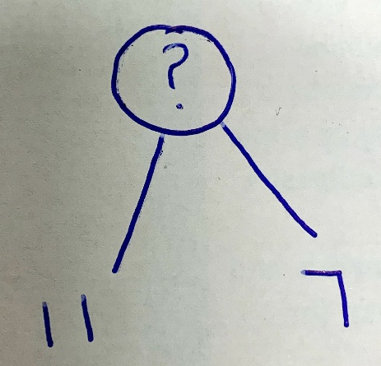  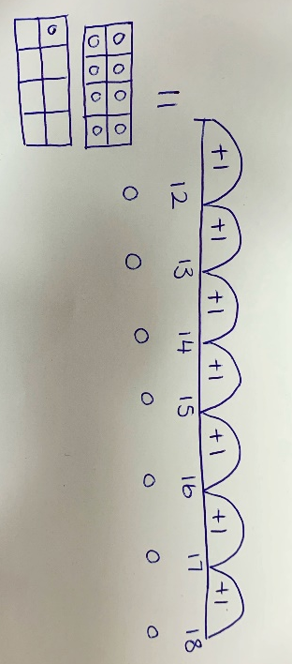 |  | 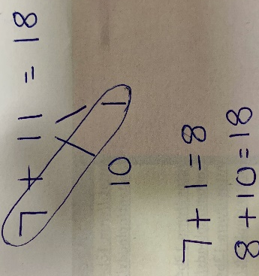  7  18
  11

Addition
Key Language: | Sum, total, parts and wholes, plus, add, altogether, more than, ‘is equal to’ ‘is the same as’, exchanging, ones, tens, commutative,
Year 2
National Curriculum  Pupils should be taught to:  - solve problems with addition and subtraction:  - using concrete objects and pictorial representations, including those involving numbers, quantities and measures  -applying their increasing knowledge of mental and written methods  - recall and use addition and subtraction facts to 20 fluently, and derive and use related facts up to 100  - add and subtract numbers using concrete objects, pictorial representations, and mentally, including:  - a two-digit number and ones  - a two-digit number and tens  - two two-digit numbers  - adding three one-digit numbers  - show that addition of two numbers can be done in any order (commutative) and subtraction of one number from another cannot  - recognise and use the inverse relationship between addition and subtraction and use this to check calculations and solve missing number problems. |  |  |  | Resources  - Part whole models  - Counters  - Tens frames  - Number tracks  - Dienes blocks  - Calculation frames  - Place value grids
Concrete |  |  | Pictorial |  |  | Abstract
Add a 2 digit number and ones- without renaming  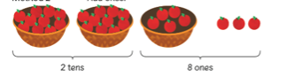  Recognise that the ones will be the only part of the number to change  25 can be partitioned in to 2 tens and 5 ones.  5 ones and 3 ones make 8 ones.  2 tens and 8 ones make the number 28  +  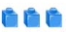 |  |  | 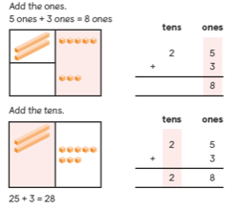  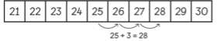 |  |  | 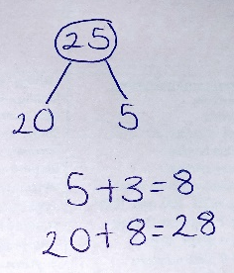
Add tens recognising the relationship to adding ones  3 2  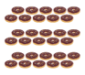  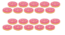 |  |  |  |  |  | Children to understand that the numbers are now ten times bigger so the whole will be ten times bigger  3 + 2 = 5  30 + 20 = 50
Adding 2-digit number and tens  Use dienes to represent the two numbers being added together.  Childre to understand that the tens are combined as they are the same. Children should count in tens as they add each tens stick on.  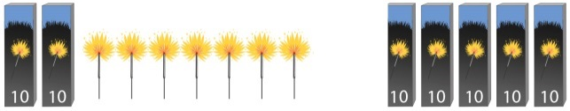 |  |  | 27  20  7  + 50 =  20 + 50 = 70  70 + 7 = 77  Chilren to partition the tens away from the ones to add separartly. |  |  | Use number tracks and understand that when you add on ten the tens column increase by 1 ten.
  27 | 37 | 47 | 57 | 67 | 77
Add two 2-digit numbers (column addition) without renaming  To add each part of the number together separarly- starting to make the relation ship to adding in columns.  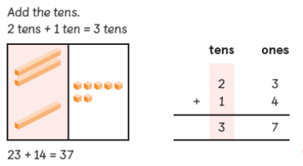  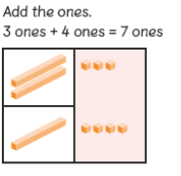 |  |  | Partition the numbers into tens and ones and add together separatly.  23  20  3  14  10  4  2 tens + 1 ten = 3 tens  3 ones + 4 ones = 7 ones  30 + 7 = 37 |  |  | 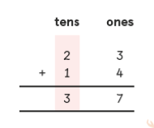  To make the links to the previous method by adding in columns starting with the ones.  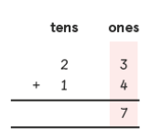
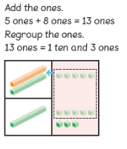  Adding with renaming- column addition  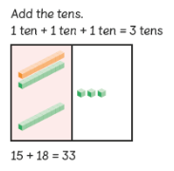 |  |  | Children to replicate the use of dienes within place value grids.  Showing renaming of the ones exceeding 9. |  |  | Using column addition to exchange.  Children to understand that 10 ones make 1 ten and cannot stay in the ones column if the total exceeds 9.  5 ones + 8 ones = 13 ones  13 ones are the same as 1 ten and 3 ones.  15  +18  3 3  1
Adding 3 single digit numbers  Children to show that they have recognised bonds to ten and then added on the addiitonal numbers left. |  | 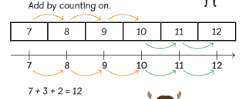 |  |  |  | 7 + 2 + 3 =  7 + 3 = 10  10 + 2 = 12  Children to recognise the bond to ten
Conceptual vairation: Find the sum of 13 and 29
 |  | 10 + 20 = 30  13  10  3  29  20  9  3 + 9 = 12  30 + 12 = 42 |  |  | 13  + 29  4 2  1

Addition
Key Language: | Sum, total, parts and wholes, plus, add, altogether, more than, ‘is equal to’ ‘is the same as’, exchanging, ones, tens, hundreds, thousands, commutative
Year 3
National Curriculum:  Pupils should be taught to:  - add and subtract numbers mentally, including:  - a three-digit number and ones  - a three-digit number and tens  - a three-digit number and hundreds  - add and subtract numbers with up to three digits, using formal written methods of columnar addition and subtraction  - estimate the answer to a calculation and use inverse operations to check answers  - solve problems, including missing number problems, using number facts, place value, and more complex addition and subtraction. |  |  |  | Resources  - Part whole models  - Counters  - Number tracks  - Dienes blocks  - Calculation frames  - Place value grids
Concrete |  | Pictorial |  |  | Abstract
Adding ones to a three digit number  212 + 4 =  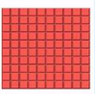 |  | 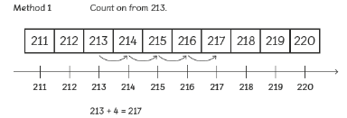  Count in steps of 1 and recognising the ones column increases by 1. |  |  | 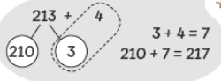  Partitioning ones from a 3 digit number and adding separately.
Adding tens to a three digit number |  | Count in steps of ten- understanding that the tens increases by 1 ten each time. |  |  | 116 + 30 =  106  10  10 + 30 = 40  106 + 40 = 146
  116 | 126 | 136 | 146
Adding hundreds |  | count in steps of 100- understanding that the hundreds increased by 1 hundred each time. |  |  | 213 + 400 =  200  13  200 + 400 = 600  600 + 13 = 613
  213 | 313 | 413 | 513 | 613
Adding two 3-digit numbers (column addition)  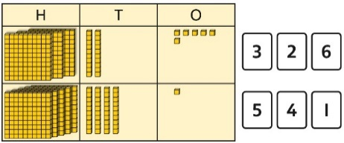 |  | Represent the place value grid using place value grids available to the children within their resources pot. Use drawings to represent. |  |  | Children to use column addition to add remembering to start from the ones column incase there is a need for exchanging.  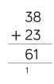
Adding two 3-digit numbers (column addition)  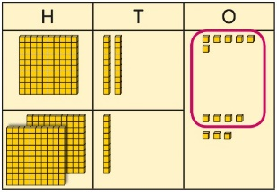  Represent the need for exchanging using dienes blocks with the children- children need a secure understanding of place value here in order to understand the need for exchanging.  6 ones + 7 ones = 13 ones  13 ones are the same as 1 ten and three ones. |  | 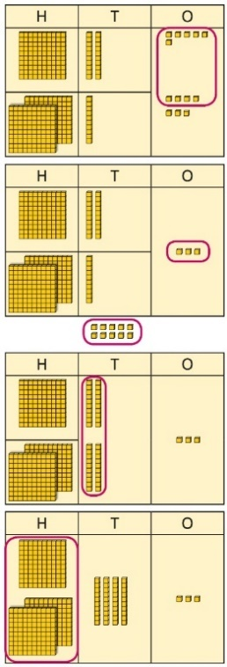  Children to represent their previous working with dienes using place value grids to support their understand for the abstract. |  |  | Children to use column addition to show where they have exchanged.  H T O  1 2 6  2 1 7  ------------  3  1  H T O  1 2 6  2 1 7  ------------  4 3  1  H T O  1 2 6  2 1 7  ------------  3 4 3  1
Conceptual variation: Find the sum on 149 + 247
 |  |  | Show the previous representation pictorially. |  |  | H T O  1 4 9  2 4 7  ------------  6  1  H T O  1 4 9  2 4 7  ------------  3 9 6  1
  H | T | O

Addition
Key Language: | Sum, total, parts and wholes, plus, add, altogether, more than, ‘is equal to’ ‘is the same as’, exchanging, ones, tens, hundreds, thousands, tens of thousands, hundreds of thousands, millions, tenths, hundredths, thousandths, commutative
Year 5
National Curriculum  - add and subtract whole numbers with more than 4 digits, including using formal written methods (columnar addition and subtraction)  - add and subtract numbers mentally with increasingly large numbers  - use rounding to check answers to calculations and determine, in the context of a problem, levels of accuracy  - solve addition and subtraction multi-step problems in contexts, deciding which operations and methods to use and why. |  |  | Resources  - place value grids  - place value counters  - number lines  - calculation frames  - decimal counters
Concrete |  | Pictorial |  | Abstract
Counting on  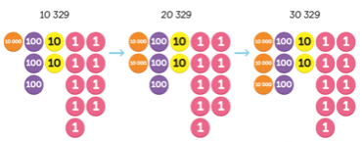 |  | Represent previous model pictorially- could use place value grids |  | 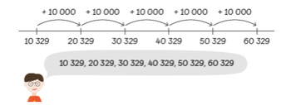  Use the counting on method using a number line or counting on mentally
Adding within 1000000 using column addition  Use place value grids and counters to create two numbers in order to add them together  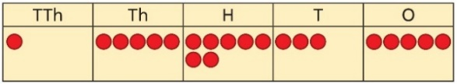 |  | 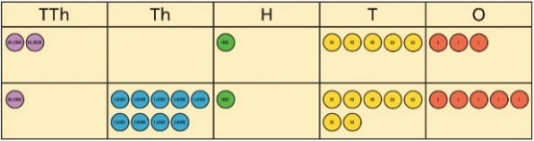  Use column addition with understanding of exchanging alongside place value grids |  | Use column addition without the need for a concrete resource to support understanding.  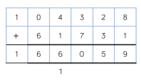
Adding decimals  Use number lines to represent each decimal and count on in tenths/hundredths.  Use place value grids and place value counters to add in columns with understand of renaming.  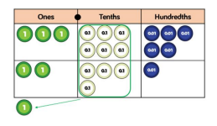 |  | 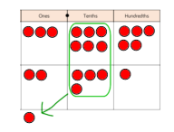  use place value grids and counters alongside column addition. |  | Use column addition without the need for concrete resources.  Add mentally using understanding of number bonds.  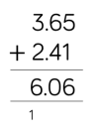

Addition
Key Language: | Sum, total, parts and wholes, plus, add, altogether, more than, ‘is equal to’ ‘is the same as’, exchanging, ones, tens, hundreds, thousands, tens of thousands, hundreds of thousands, millions, tenths, hundredths, thousandths, commutative
Year 6
National Curriculum  - solve addition and subtraction multi-step problems in contexts, deciding which operations and methods to use and why |  |  | Resources  - place value grids  - place value counters  - number lines  - calculation frames  - decimal counters
Concrete |  | Pictorial |  | Abstract
Continue to develop previous skills using column addition when necessary (Year 5)

