

Mathematics Calculation Policy

Multiplication
Key Language: | Double, twice as many, groups, the same, equal to
Reception
ELG  - Automatically recall (without reference to rhymes, counting or other aides) number bonds up to 5 (including subtraction facts) and some number bonds to 10, including double facts.  - Explore and represent patterns within numbers up to 10, including evens and odds, double facts and how quantities can be distributed equally |  |  | Resources  - Objects for counting  - Numicon  - Tens frames  - Multilink/unifix  - Part whole models  - Calculation frames
Concrete |  | Pictorial |  | Abstract
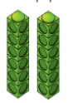  Understanding equal groups   |  | 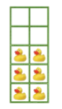  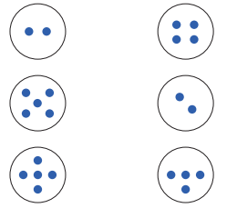 |  | Part whole models/tens frames to complete number sentences.  4 split into equal groups can be  1 and 1 and 1 and 1 or 2 and 2.
Understanding doubling ‘twice as many’  Use physical objects to show doubling as two equal groups or twice as many    c   |  | Doubling ladybirds  Children can see two groups being made when they paint one side and press together.  Use part whole models to represent two equal groups.  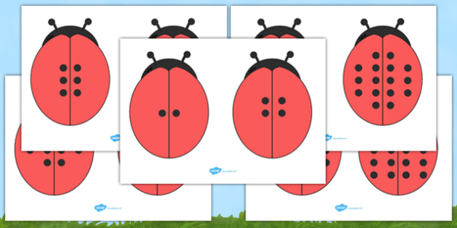  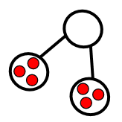 |  | Use part whole models with numbers instead of objects or dots.  4  2  2  Use number sentences:  2 doubled is 4  2 + 2 = 4
Conceptual Vairation: double five.
   |  | 10 |  | 10  5  5

Multiplication
Key Language: | Group, equal, double, twice as many, rows/arrays, equal to, product
Year 1
National Curriculum  - solve one-step problems involving multiplication and division, by calculating the answer using concrete objects, pictorial representations and arrays with the support of the teacher. |  |  | Resources  - counters/objects for counting  - part whole models  - multilink
Concrete |  | Pictorial |  | Abstract
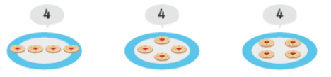  Making equal groups  Children to understand the meaning of equal groups. Each group must have the same amount in each. |  | Children to organise groups to ensure that they are equal  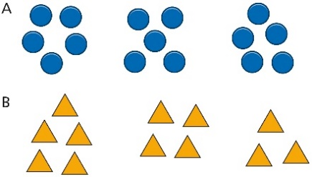 |  | children to represent the equal parts and how many groups there are through using a part whole model.  12  4  4  4  Children to use sentences to represent the equal groups.  There are 3 equal groups of 4
Adding equal groups (2,5,10)  Pupils start to count in multiples of 2 and multiples of 10, then progress to counting in multiples of 2, 5 and 10 supported by discrete, countable representations.  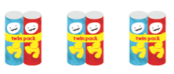  2 4 6 |  | Use tens frames to support children in counting in equal groups. |  | Children to use number tracks to support them in counting up in equal groups/steps.
  2 | 4 | 6
Making equal rows  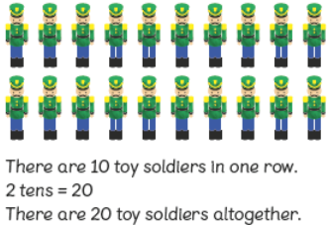 |  | Use arrays as a way of representing groups and how many within a group.  There are 2 groups of 10.  2 tens are 20 |  | Children can make the link between equal groups and repeated addition.  Use number sentences from this.  10 + 10 = 20
Making doubles  Start with using objects and getting children to show what doubling means.  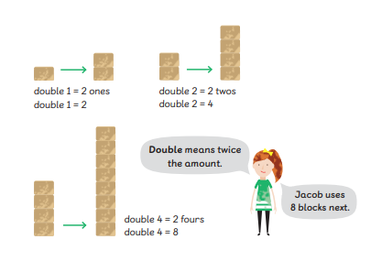  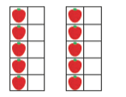  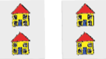 |  | Use a part whole models to represent two equal groups coming together to make the whole. |  | Use part whole models to represent two equal groups coming together to create the whole.  8  4  4  Or use stem sentences- children should understand that double means 2 groups of the same number  4 doubled is 8  2 groups of 4 make 8  Partitioning to double then adding together  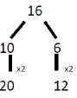
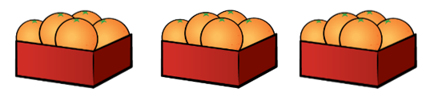
Conceptual Variation: How many oranges are there all together?
3 groups of 5 |  | 15  Or count in steps of 5 |  | 15  5  5  5  Or children should use stem sentences and their understanding of number bonds  3 groups of 5  3 fives are 15
  5 | 10 | 15

Multiplication
Key Language: | Double, times, multiplied by, the product of, groups of, lots of, ‘is equal to’ ‘is the same as’, array, commutative
Year 2
National Curriculum  - recall and use multiplication and division facts for the 2, 5 and 10 multiplication tables, including recognising odd and even numbers  - calculate mathematical statements for multiplication and division within the multiplication tables and write them using the multiplication (×), division (÷) and equals (=) signs  - show that multiplication of two numbers can be done in any order (commutative) and division of one number by another cannot  - solve problems involving multiplication and division, using materials, arrays, repeated addition, mental methods, and multiplication and division facts, including problems in contexts |  |  | Resources  - Counters  - Number tracks  - Tens frames  - Part whole models  - Multilink  - Number lines  - Dot cards
Concrete |  | Pictorial |  | Abstract
Multiplication as equal groups  Recognise that the groups are equal.  4 groups of 3  4 3’s    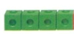 |  | Par whole models to show how many groups of a number make the product  Arrange counters into equal groups and count in steps of how many are in each group.   |  | 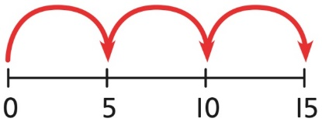  Multiplication as repeated addition. Children to understand that they are adding on the same amount each time and can therefore use number lines and addition sentences to support them in finding the product.  4 + 4 + 4 =  3 groups of 4  3 x 4 =
Counting in 2’s  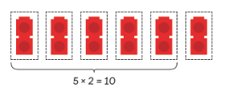  Understand that counting in two’s means counting 2 in each group  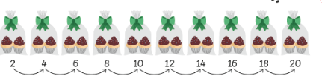 |  | Children to use arrays to support them in counting in two’s- represent the equation using counters. |  | 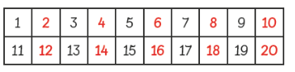  Children to use number tracks to support them in counting in twos.  Children to use recall of two times tables to solve equations.  5 x 2 = 10
Associated facts  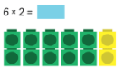  To use key facts to support retrieval of other key facts- key facts to include 10s 5s and 2s |  | 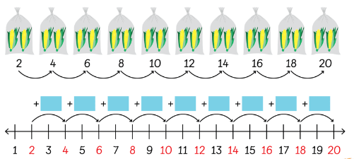  number lines used to represent adding on ____ more groups. |  | Abstracting mentally-  I know 5 x 2 = 10 so 6 x 2 is 2 more than 10.
Counting in 5’s  Understanding that counting in fives means there are five in each group and increase by 5.    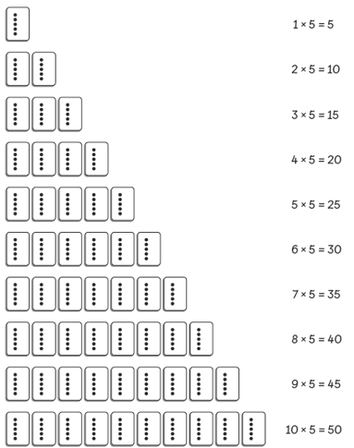  Use dot cards to show that numbers are increasing by 5 as you work further up the five times tables  . |  | Use arrays to show grouping in fives.  Part whole models  15  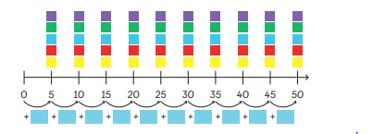 |  | Use repeated addition  5 + 5 + 5 =  3 x 5 =  Children to use known number facts to support them in solving the equation:  2 x 3 = 10 + 5 = 15
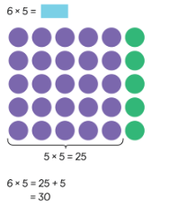  Associated facts |  |  |  | Abstracting mentally-  I know 5 x 5 = 25 so 6 x 5 is 5 more than 25.
Counting in 10s    Count in steps of ten.  10, 20, 30  Children understand the tens column increases by 1 each time 10 is added.  Use dienes to represent 1 group of 10  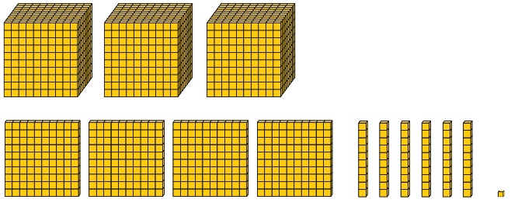 |  | Use related facts of counting in tens to support children in recalling times table facts  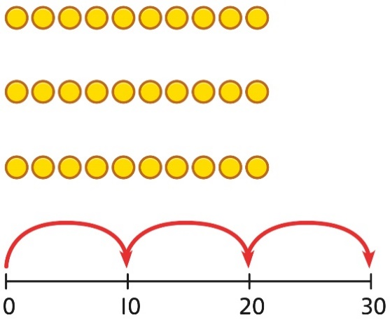  children to use arrays and number lines to support them in understanding that when you are multiplying, all groups are equal. |  | Use repeated addition to show the same amount being added on.  10 + 10 + 10 = 30  3 groups of 10  3 x 10  Children to use known facts from the ten times tables to support them in quick recall.  4 x 10 = 40  3 x 10 = 40 – 10  3 x 10 = 30
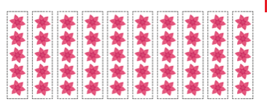  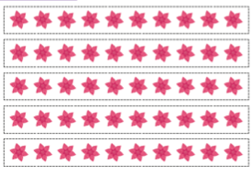  Understanding commutativity  Children to use arrays to represent two equations with the same numbers in but swapped. E.G  10 groups of five or 10 x 5  5 groups of ten or 5 x 10  Children to explore what this shows |  | Continue to represent arrays using pictures to show that it multiplication is commutative.  Children to use repeated addition to show the difference in grouping.  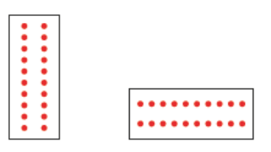  10 x 2 = 20 2 x 10 = 20  2 + 2 + 2 + 10 + 10 = 20  2 + 2 + 2 +  2 + 2 + 2 +  2 = 20 |  | Children to use repeated addition and multiplication equations without concrete resources.  5 x 2 = 10  2 + 2 + 2 + 2 + 2= 10  2 x 5 = 10  5 + 5 = 10
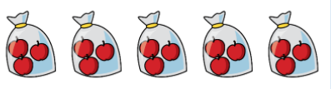
Conceptual Variation:

3 + 3 + 3 + 3 + 3 = 15  5 + 5 + 5 = 15 |  | 3  15  3  3  3  3 |  | 5 x 3 = 15  Or  3 x 5 = 15  3 + 3 + 3 + 3 + 3 = 15  5 + 5 + 5 = 15

Multiplication
Key Language: | Double, times, multiplied by, the product of, groups of, lots of, ‘is equal to’ ‘is the same as’, array, commutative
Year 3
National Curriculum  - recall and use multiplication and division facts for the 3, 4 and 8 multiplication tables  - write and calculate mathematical statements for multiplication and division using the multiplication tables that they know, including for two-digit numbers times one-digit numbers, using mental and progressing to formal written methods  - solve problems, including missing number problems, involving multiplication and division, including positive integer scaling problems and correspondence problems in which n objects are connected to m objects. |  |  | Resources  - counters  - Dienes  - Place value grids  - Number lines/tracks  - Multilink  - Part whole models  - Bar models  - Place value counters
Concrete |  | Pictorial |  | Abstract
Multiplying by 3  Count in steps of 3 using a number line. Children to understand that at each jump we add on three more than the previous number. (building additive understanding of multiplication- supporting from year 2 )  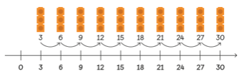 |  |   Use arrays to support the children in representing a multiplication equation. |  | Children to use known number facts to support them in solving other multiplication equations    2 x 3 = 6  So  4 x 3 = 12  The amount of groups has doubled so the product will double.  4 x 3 = 12  So  5 x 3 = 15  There is an additional group so the product is three more than the previous product.  6 x 3 = 18  So  5 x 3 = 18 – 3
  18
  3 | 3 | 3 | 3 | 3 | 3
Multiplying by 4  #  Children to use counters to create arrays to support them |  | 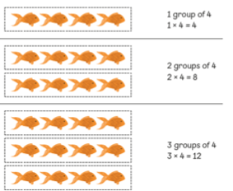 |  | Children to use known number facts to support them in finding the products of multiplication equations.  Children should also begin to use quick recall if the four times tables.   10 x 4 = 40  So 9 x 4 = 40 – 4 = 36
  12
  4 | 4 | 4
Relationship between 4 and 8  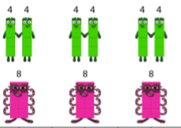  Children to spend time understanding the relationship between 4 and 8. Understanding that 8 is double four and four is half of eight.  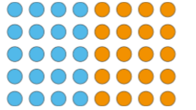  Create arrays ensuring that two parts of 4 are clear. Children to see that two groups of four are the same as 1 group of 8. |  | 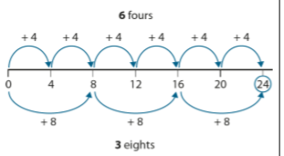  Use a number line to support understanding of the relationship between counting in fours and counting in eights.  Children will see that you will not find all multiples of four in the eight times tables. |  | 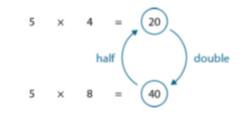  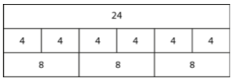  Children to use bar models to abstract the relationship between four and eight times tables.  Children to model their understanding of how to use the bar model to support them in counting in eights from their understanding of counting in fours.  e.g 4 x 4 = 16  4 x 8 = 32
Multiplying by 8  Use arrays as they would have done previously to represent the multiplication equation.  Ensure that children understand the concept of commutativity so that the array can be either way around.  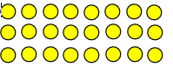 |  | 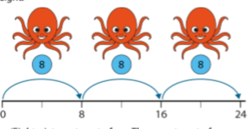  Children to use a number line to show that they are adding on 8 each time they make a jump from one product to the next. Children should recognise that each jump represents one group of 8.  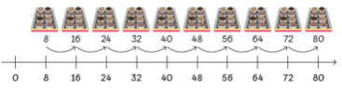 |  | Children recall 8 times tables mentally without the need for counting on fingers etc.  Children to recall 8 times tables using known number facts and 4 times tables to support.  E.g 5 x 8 = 40  so 6 x 8 = 48  or  6 x 4 = 24  So  6 x 8 = 48  The amount in each group has doubled therefore the product will double.
Using known facts to multiply multiples of ten  using dienes explore what is the same and what is different about the two sets of dienes. Children to make the link of using tens as a replacement for the ones makes the answer ten times bigger as the representations has been unitised differently.  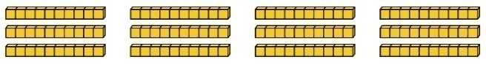 |  | Unitising the ones in to tens showing that they are becoming ten times bigger.  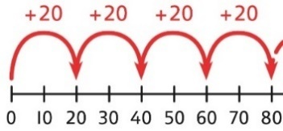  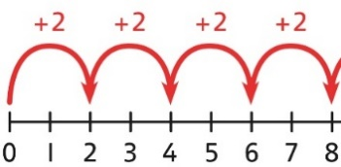  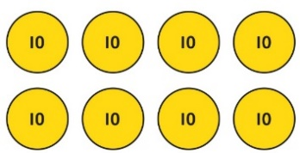  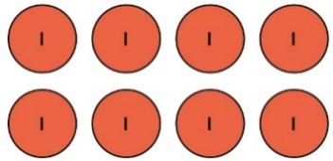  2 groups of 4 ones = 8 ones  2 groups of 4 tens = 8 tens  So 2 x 4 = 8  And 2 x 40 = 80 |  | Children to use known number facts to support them when answering an equation where they are multiplying a one digit number by a multiple of ten.  4 x 2 = 8  40 x 2 = 80
Multiplication 2 digit number by a 1 digit number  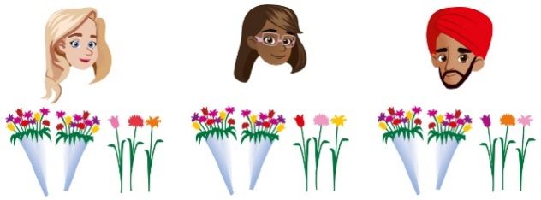  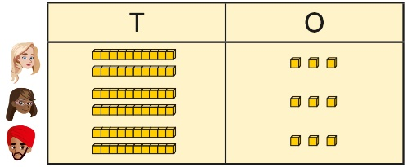 |  | Represent the place value grid pictorially.  23  20  3  Partition the two digit number and then use known multiplication facts to multiply the two parts together and then add the products together.  20 x 3 = 60  3 x 3 = 9  60 + 9 = 69 |  | Use expanded column method.  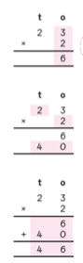
Multiplying with regrouping  Ensure that children understand that they will need to regroup the ones as there are more than 10 and therefore become 1 ten and the remaining ones.  23 x 4 =  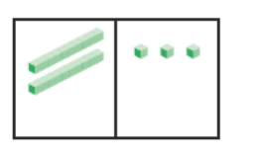  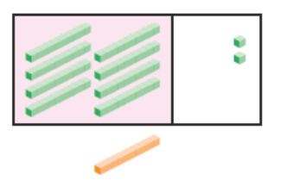  3 x 4 = 12  12 = 1 ten and 2 ones  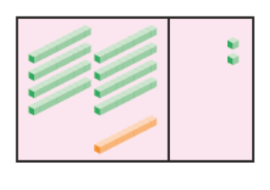  20 x 4 = 80  80 + 12 = 92 |  |  |  | 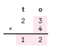  use the expanded column method to support with renaming.  Multiply the ones  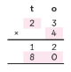  Multiply the tens  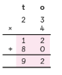  Add the ones and tens together to get the product.
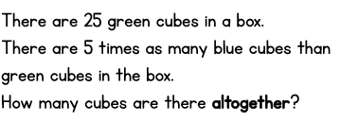
Conceptual Variation :
 |  | 25  20  5  20 x 5 = 100  5 x 5 = 25  100 + 25 = 125 |  | h t o  x 2 5  5  2 5  1 0 0  1 2 5
  T | O
  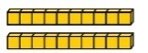
  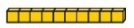

Multiplication
Key Language: | Double, times, multiplied by, the product of, groups of, lots of, ‘is equal to’ ‘is the same as’, array, commutative, factor
Year 4
National Curriculum  - recall multiplication and division facts for multiplication tables up to 12 × 12  - use place value, known and derived facts to multiply and divide mentally, including: multiplying by 0 and 1; dividing by 1; multiplying together three numbers  - recognise and use factor pairs and commutativity in mental calculations  - multiply two-digit and three-digit numbers by a one-digit number using formal written layout  - solve problems involving multiplying and adding, including using the distributive law to multiply two digit numbers by one digit, integer scaling problems and harder correspondence problems such as n objects are connected to m objects |  |  |  | Resources  - Counters  - Dienes  - Place value grids  - Number lines/tracks  - Multilink  - Part whole models  - Bar models  - Place value counters
Concrete |  |  | Pictorial |  |  | Abstract
Counting in sixes, sevens and nines  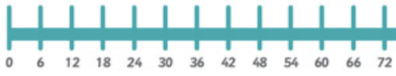 |  |  | 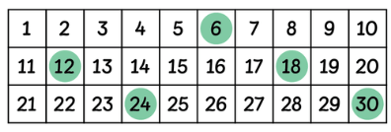  When pupils know that the size of a group is 6, 7 and 9 and the group size remains consistent, they can count in multiples of 6, 7 and 9 to find the product. |  |  | Count confidently without key manipulatives.
Multiplying by 6  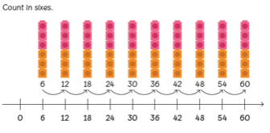  use number line to show that each time we add on an additional group we are adding on 6 to the previous product. |  |  | Children to make the relationship from counting in 6’s to counting in 3’s  3 x 3 = 9  3 x 6 = 18  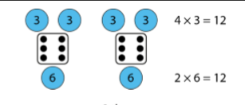  children to notice the relationship between x by 3 and x by 6. 6 is double 3.  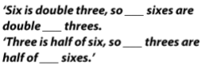 |  |  | Use recall to answer equations  3 x 6 = 18  Children to support their quick recall by using known number facts  3 x 5 = 15  3 x 6 = 15 + 3
Multiplying by 7
Repeat similar processes to multiplying by 6.
Multiplying by 9  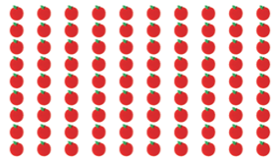  Children to create arrays using various counting objects.  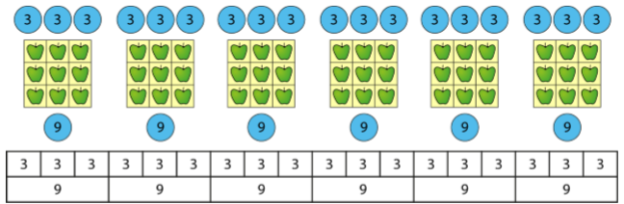  Children to understand the 1 group of nine is the same as 3 groups of 3. Children can therefore use their 3 times tables to support them when counting in multiples of nines |  |  | 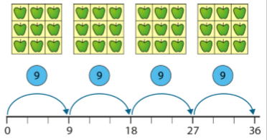  Children to understand that when you are counting in groups of nine you are adding on nine to the previous factor.  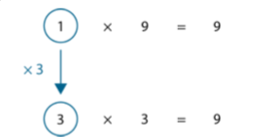  Children to make the links between counting in threes through using bar models to support them. |  |  | Children to use quick recall to answer the equation.  Children can use know number facts to support them.  4 x 9 = 45 – 9  Use known facts within the three times tables to support answering equations in the nine times table.
Multiplying by 11  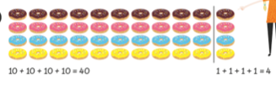  Children to use the distributive law to support them when counting in multiples of 11. Understand that they are counting in 10’s + 1. |  |  | 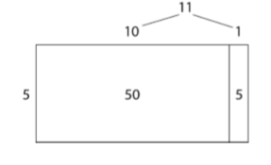  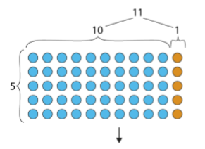  use the distributive law through showing that they have partitioned 11 and multiplied each factor by 5 and then added them together. |  |  | Children to use bar models to support them in writing their equations and finding the product.  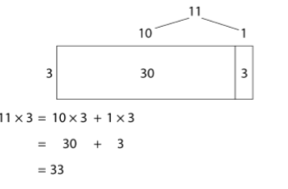  Children to recall 11 times table facts using known facts to support them.  7 x 11 = 55 + 11 + 11
Multiplying by 12
Use methods similar to multiplying by 11
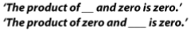  Multiplying by 0 and 1  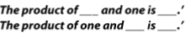  Children to understand that when zero is a factor, the product is always zero.  and  when one is a factor, the product is the same as the other factor.  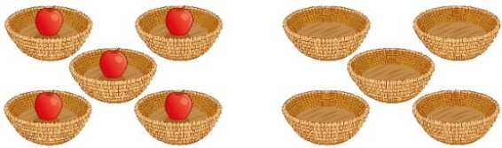 |  |  | Represent pictorially |  |  | Children to understand that when zero is a factor, the product is always zero.  and  when one is a factor, the product is the same as the other factor.  So  5 x 0 = 0 because a factor is zero so the product will be zero  And  5 x 1 = 5 as one of the factors is one therefore the remaining factor and the product are the same.
Multiplying the same two numbers  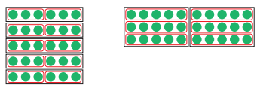  Arrays are used to support the understanding of commutativity. Pupils learn the pattern of a × b = b × a. Regardless of the order in which the factors are multiplied, the product remains the same. |  |  | 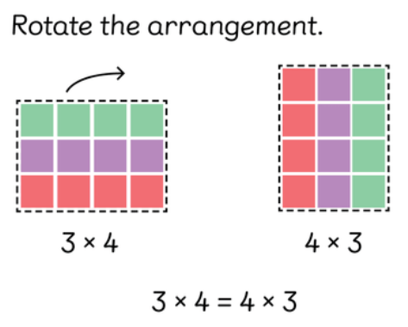 |  |  | Children to abstract equations  3 x 4 = 12 so 4 x 3= 12  I know 3 x 4 = 12 so 4 x 3 = 12
multiplying 3 numbers  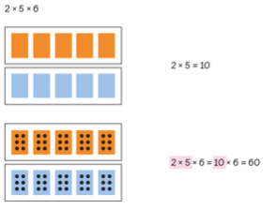  children to plot the array for to represent the first two factors within the equation and then represent the final factor within each part of the array. |  |  | Children to use their understanding of commutativity to support them in solving each equation through finding the most efficient way to find the product.  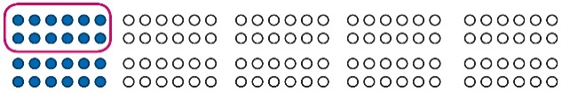  2 × 6 × 10 = 120  12 × 10 = 120  10 × 6 × 2 = 120  60 × 2 = 120  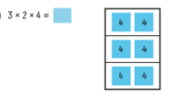  Abstract the previous array to represent the equation. |  |  | Use knowledge of factors to simplify some multiplications.  24 × 5 = 12 × 2 × 5  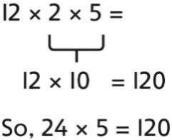  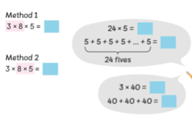  Children to continue to use their understanding of commutativity, known factors and use repeated addition if necessary.
Multiplying by multiples of 10  Children should have a good understanding for unitising numbers as 1’s 10’s or 100’s  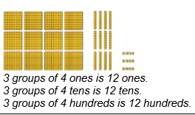  Use dienes to represent/unitise the multiple of ten. Create groups to represent the equation.  3 x 40 =  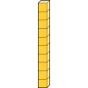   |  |  | Represent pictorially. |  |  | Children to use repeated addition understanding how many groups they are going to be adding and what will be in each group.  40  40  40  120  Use known number facts  3 x 4 = 12  3 x 40 = 120  One factor is ten times bigger therefore the product will be 10 times bigger
Multiplying 2 digit numbers  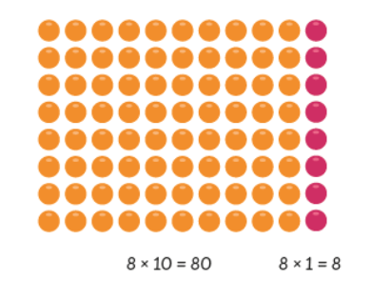  Partitioning- no renaming  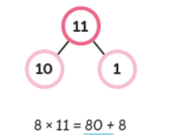Children can partition 2 digit numbers into smaller factors to support them in using known facts to solve the equation.  3  10  3  10  10  3  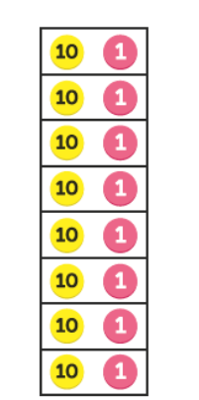  Children can also use PV counters to support them in creating groups. Children can then mentally add the ones and then the tens.  Compact- renaming  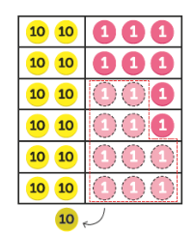  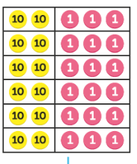  use PV counters as you would have previously to support with using known facts to multiply |  |  | 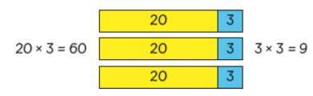  Partitioning  3 x 8= 24  10 x 8= 80  3  10  10  3  3  10  10  3  10  3  Compact- renaming  Represent pictorially |  |  | Partitioning  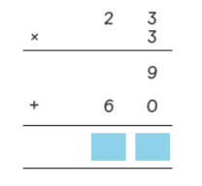  Children can use expanded column multiplication however they should be able to move on from this towards the end of the unit.  Compact- renaming- children should be secure in this by the time they leave year 4  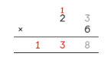  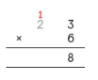  Children to use their understanding of renaming to support them when using compact column multiplication.
Multiplying by multiples of 100  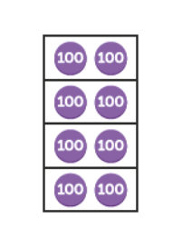  4 x 200 = 800  Children should be able to count in multiples of 100 and 2 and can use these to support them when using PV counters to multiply multiples of 100. |  |  | Represent pictorially |  |  | 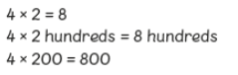  Children to use known facts to support them when multiplying by 100.  The factor is 100 times more than the known fact therefore the product will be 100 times more than the product when multiplying with known facts.
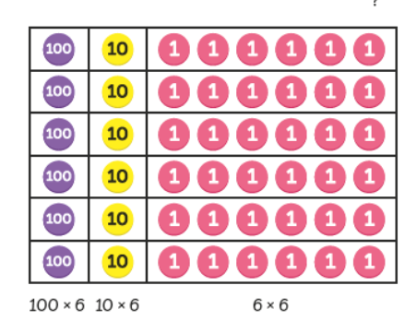  Multiplying 3 digit numbers  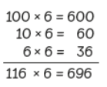  600 + 60 + 36 = 696  Children should be able to create the 3 digit number they are multiplying using PV counters and begin to create the amount of groups needed-looking at the other factor in the equation to know how many groups are needed. |  |  | Represent pictorially |  |  | 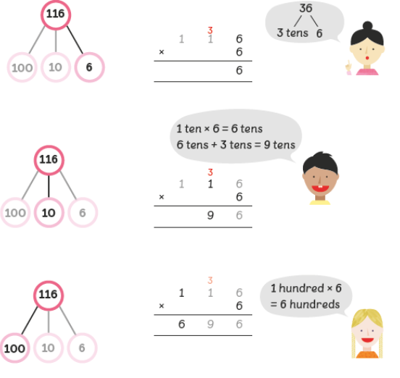  use part whole models to support with unitising and therefore support when multiplying and renaming (supports most when moving away from expanded column multiplication)
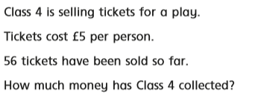
Conceptual variation:
5 x 50 = 250  5 x 6 = 30  56 x 5 = 280  £280 |  | 6  50  6  50  50  6  50  6  6  50 |  |  | 3  5 6  x 5  2 8 0

Multiplication
Key Language: | Double, times, multiplied by, the product of, groups of, lots of, ‘is equal to’ ‘is the same as’, array, commutative, factor, square, cubed, prime, composite
Year 5
National Curriculum  - identify multiples and factors, including finding all factor pairs of a number, and common factors of two numbers  - know and use the vocabulary of prime numbers, prime factors and composite (nonprime) numbers  - establish whether a number up to 100 is prime and recall prime numbers up to 19  - multiply numbers up to 4 digits by a one- or two-digit number using a formal written method, including long multiplication for two-digit numbers  - multiply and divide numbers mentally drawing upon known facts  - multiply and divide whole numbers and those involving decimals by 10, 100 and 1000 |  |  | Resources  - counters  - Dienes  - Place value grids  - Number lines/tracks  - Multilink  - Part whole models  - Bar models  - Place value counters  - Decimal place counters
Concrete |  | Pictorial |  | Abstract
Finding multiples  Using counters and arrays to support understanding of multiples.  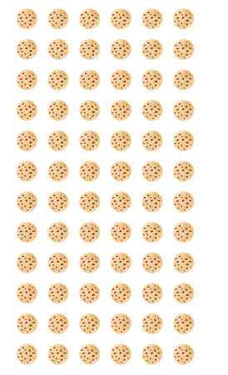 |  | Represent pictorially |  | 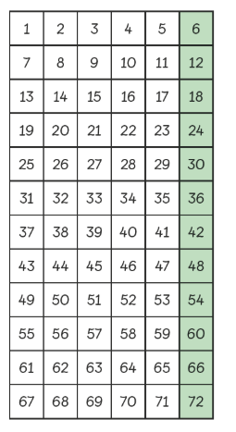  use understanding of times table facts to support understanding of multiples.  or
Finding factors  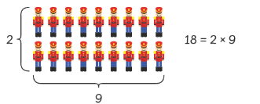  Spend time exploring how a product can be put into a variety of equal groups.  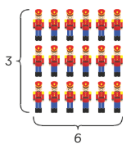  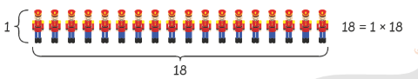 |  | Represent pictorially |  | Use times table knowledge to support knowledge of factors.
Finding common factors  Finding factors using methods above |  | Represent pictorially |  | 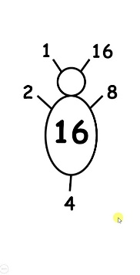
Finding prime numbers/composite numbers  Spend time exploring how products can be put into equal groups- drawing attention to those who only have two factors.  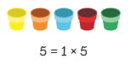    Composite numbers are numbers which are not prime. |  | Representing pictorially |  | Use known multiplication facts to support with prime numbers
Finding square and cubed numbers  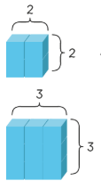  using cubes or counters to support understanding of cubed numbers |  | Represent pictorially |  | 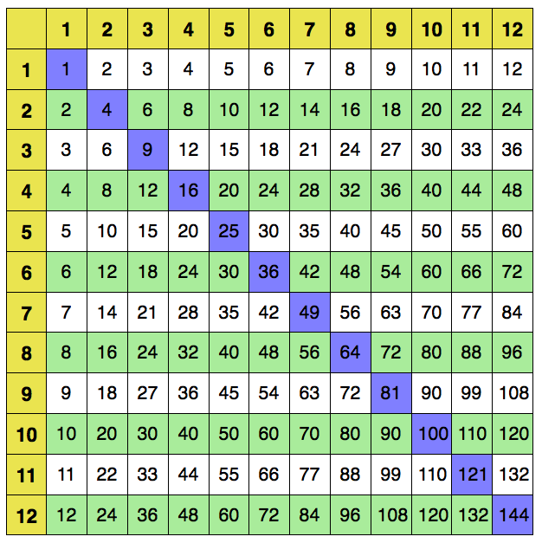  identify patterns using a multiplication grid.
Multiplying by 10, 100 and 1000  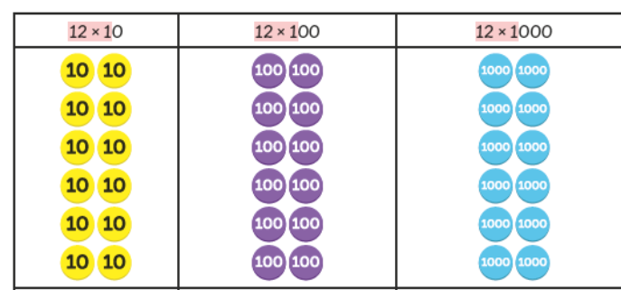  spend time unitising using PV equipment to support. Dienes blocks are good here as they show each unit as ten times bigger than the unit before. |  | Represent pictorially |  | Children to use their understanding from unitising with PV equipment and their understanding of known facts to support them when multiplying by 10, 100 or 1000  12 x 10 = 120  12 x 100= 1200  12 x 1000 = 12000
Multiplying by 2 digit and 3 digit numbers by a single digit  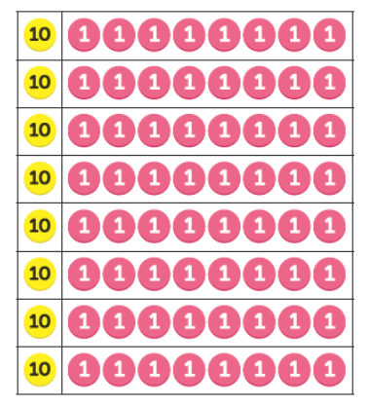  18 x 8 =  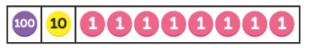  118 x 3 = |  | Represent pictorially |  | 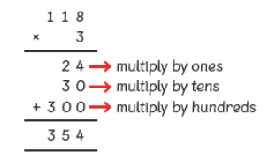  1 8  X 8  64 multiply by ones  80 multiply by tens  1 4 4  Or (this should be secure by the time children leave)  6  2  118 18  X 3 x 8  3 5 4 144
Multiplying 4 digit numbers  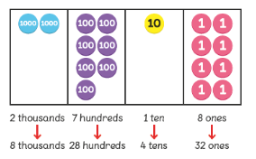  2718 x 4 =  or  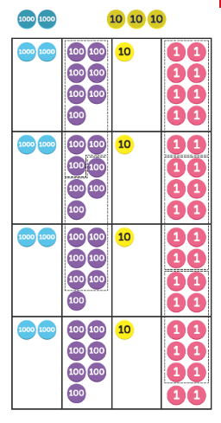 |  | 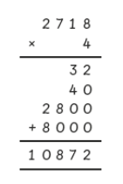  Represent pictorially |  | 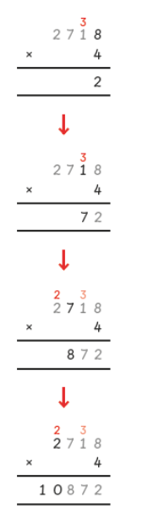  Children to use their understanding of unitising to support them when they are using short multiplication.
Multiplying a 2 digit number by a 2 digit number  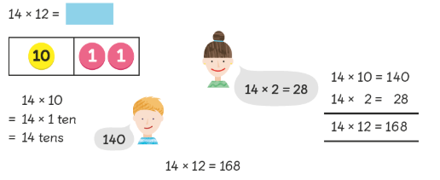  use of place value counters to support children partitioning one of the two digit numbers and then using known facts to multiply. |  | 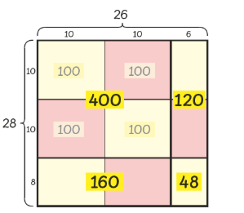  ‘grid method’ approach with children. |  | 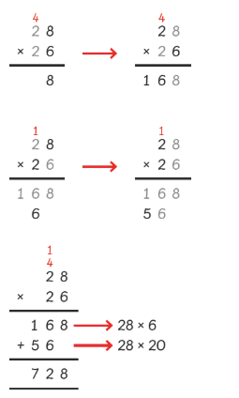
Multiplying a 3 digit number by a 2 digit number  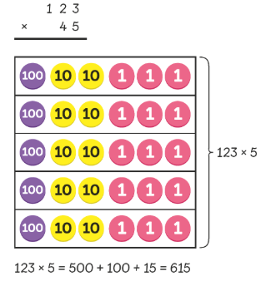  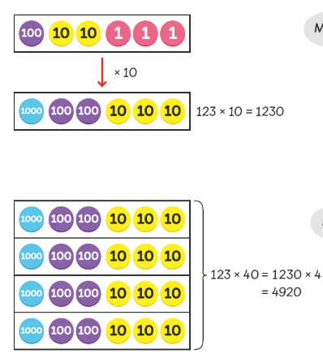 |  | Represent pictorially |  | 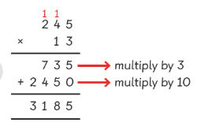  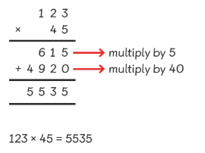  with renaming
Multiplying fractions by whole numbers  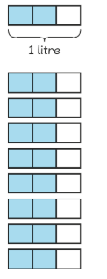  use bar models to support multiplication of fractions by a whole number |  | Represent pictorially |  | 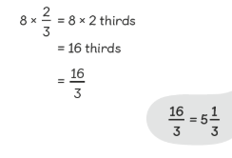  multiplying the numerator by the whole number.
Multiplying mixed numbers  Children to draw bar models to support their understanding.  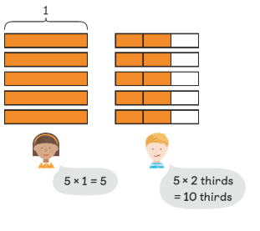  1 2/3 x 5= |  | Represent pictorially |  | 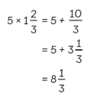  children to multply the numerator by the whole number and then the mixed number by thre whoole number- simlify the fraction if needed.
Conceptual variation 234 x 44
X 10  Show renaming within each column |  | Show pictorially |  | 2 3 4  1  1  1  X 4 4  9 3 6 (234 x 4)  9 3 6 0 (234 x 40)  1  10 2 9 6

Multiplication
Key Language: | Double, times, multiplied by, the product of, groups of, lots of, ‘is equal to’ ‘is the same as’, array, commutative, factor, square, cubed, composite
Year 6
National Curriculum  - multiply multi-digit numbers up to 4 digits by a two-digit whole number using the formal written method of long multiplication  - perform mental calculations, including with mixed operations and large numbers identify common factors, common multiples and prime numbers  - use their knowledge of the order of operations to carry out calculations involving the four operations  - solve addition and subtraction multi-step problems in contexts, deciding which operations and methods to use and why  - multiply simple pairs of proper fractions, writing the answer in its simplest form [for example, 4 1 × 2 1 = 8 1 ]  - multiply one-digit numbers with up to two decimal places by whole numbers |  |  | Resources  - counters  - Dienes  - Place value grids  - Number lines/tracks  - Multilink  - Part whole models  - Bar models  - Place value counters  - Decimal place counters
Concrete |  | Pictorial |  | Abstract
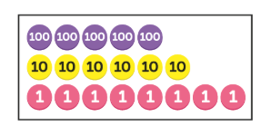  Multiplying 2/3/4 digit numbers by a 2 digit number  12 x 568 =  Children to spend time unitising- recalling 10 ones= 1 ten etc  Children to use place value counters to support them when multiplying |  | Represent pictorially |  | 568  12  16  120  1000  80  600  5000  Or compact column multiplication  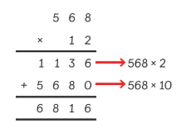  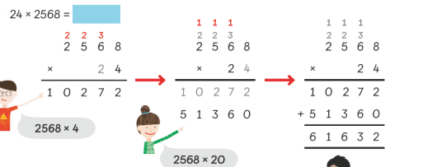  (Step by step)
Multiplying fractions  ¼ x 1/3  Divide each of the quarters in to 1/3 as all parts must be equal. Look at the section of the whole needed to find a 1/3 of and shade a 1/3 of each of the parts of the whole.  1/3 of a ¼  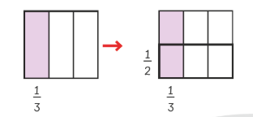  ½ x 1/3 = 1/6  Children to create models to support them when x a fraction. |  | Represent pictorially |  | ½ x 1/3 =  Multiply the numerators then the denomitors.  1 x 1 = 1  2 x 3 = 6  Simplify if possible.
Multiplying decimals  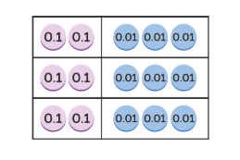  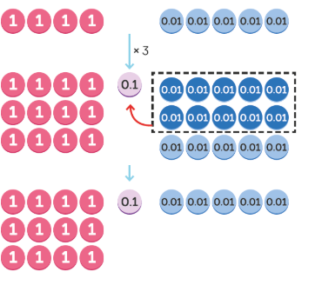  With renaming |  | Represent pictorially. |  | 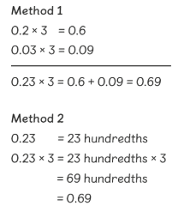  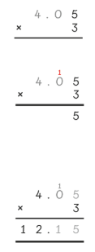  With renaming
Muliplying decimals by a 2 digit number  3.4 x 16 =  3.4 x 10 = 34  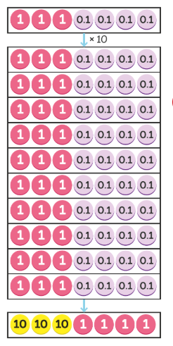  3.4 x 6 = 20.4 |  | Represent pictorially |  | 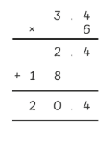  Or  2  3.4  6  24 .4
Conceptual variation: 1.96 x 7
6
4
Show renaming in each column  0.06 x 7 = 0.42  0.9 x 7 = 6.3  1 x 7 = 7  0.42 + 6.3 + 7 = 13.72 |  | Represent pictorially |  | 1.96  X 7  13.72
  

