

Mathematics Calculation Policy

Division
Key Language: | Half, halved, groups, equal, fair, unfair, unequal, odd, even
Reception
ELG  - Explore and represent patterns within numbers up to 10, including evens and  - odds, double facts and how quantities can be distributed equally. |  |  | Resources  - multilink  - numicon  - part whole  - objects to count  - tens frames  - number lines
Concrete |  | Pictorial |  | Abstract
Halving  Understanding halving as sharing equally/fairly between 2 things  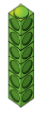  Children to move objects between two groups making sure the groups   |  | sharing between 2 groups- children to check the groups are equal |  | Part whole model- children to check the 2 groups add to give the whole (how many they started with)  4  2  2
Odds and evens  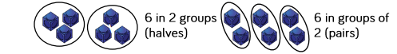  Children to understand that numbers that can be shared/halved equally are even and those that can’t are odd.  use multilink to show that the numbers can be halved or paired equally.  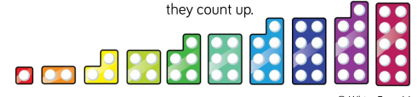  Numicon to show that the groups cannot be shared equally between two/ do not have pairs and one left on its own |  | 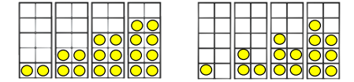  children to draw into tens frames to show odd and even numbers- similar pattern to numicon. |  | 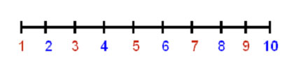  Children to recognise the pattern of odd and even numbers.
Conceptual Vairation: Can you share 7 equally?
7
3
4

Division
Key Language: | Half, halved, groups, equal, fair, unfair, unequal, odd, even, sharing, grouping
Year 1
Year 1  - solve one-step problems involving multiplication and division, by calculating the answer using concrete objects, pictorial representations and arrays with the support of the teacher. |  |  | Resources  - counters  - objects for counting  - number lines  - multilink
Concrete |  | Pictorial |  | Abstract
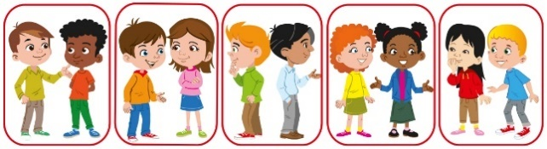  Grouping  There are 10 children altogether.  There are 2 in each group.  There are 5 groups.  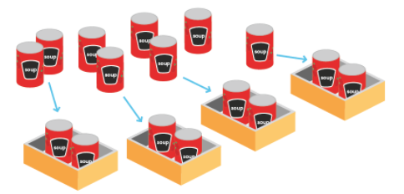  There are 8 cans of soup altogether.  There are 2 in each group.  There are 4 groups. |  | Using counters to create equal groups    There are 10 children altogether.  There are 2 in each group.  There are 5 groups. |  | 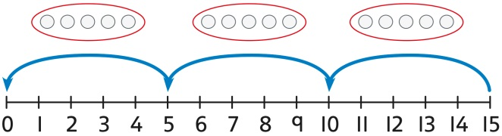  skip counting
Sharing  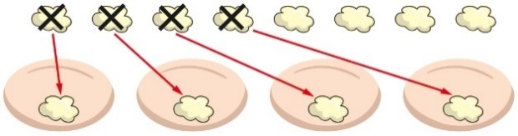 |  | 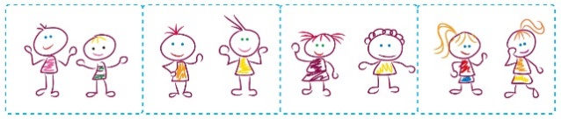  children to draw groups and share objects between each group  Children could also use multilink/counters |  | Use of stem sentences:  10 shared into 2 equal groups gives 5 in each group.
Conceptual Vairation: I have 10 cubes. If I put them into groups of 2, how many groups will I have?
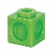 |  |  |  | use of a number line to show that they have made jumps of 2 to 10

Division
Key Language: | Half, halved, groups, equal, fair, unfair, unequal, odd, even, sharing, grouping, dividing
Year 2
Year 2  - recall and use multiplication and division facts for the 2, 5 and 10 multiplication tables, including recognising odd and even numbers  - calculate mathematical statements for multiplication and division within the multiplication tables and write them using the multiplication (×), division (÷) and equals (=) signs  - show that multiplication of two numbers can be done in any order (commutative) and division of one number by another cannot  - solve problems involving multiplication and division, using materials, arrays, repeated addition, mental methods, and multiplication and division facts, including problems in contexts. |  |  | Resources  - counters  - tens frames  - number lines  - bar model  - plates
Concrete |  | Pictorial |  | Abstract
  Grouping  Use of arrays to group- children to see the link between multiplying and dividing. |  | 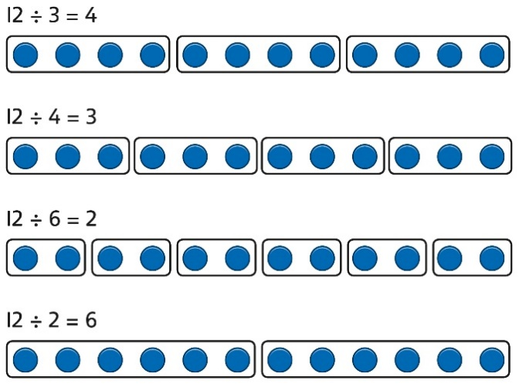 |  | 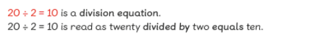  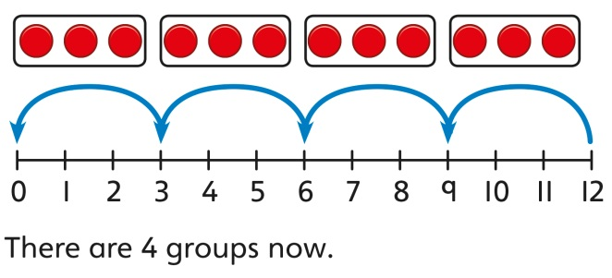  or  or  20  10  10
Sharing  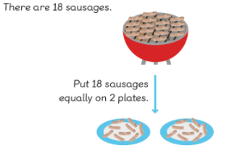  or  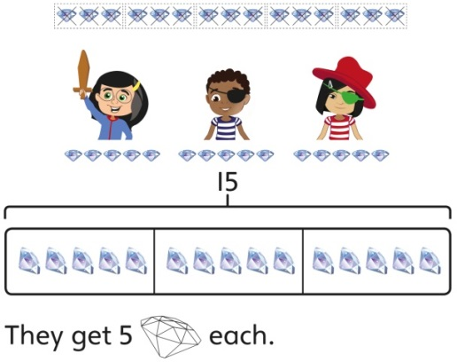 |  | Sharing between groups:  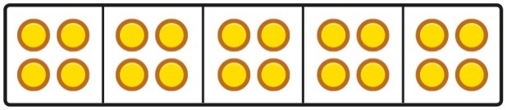  Plates/squares  or |  | Sharing between groups- using a bard model  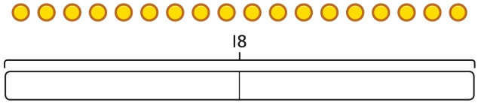  Or  18 share equally between two groups leaves 9 in each group.
Dividing by 2  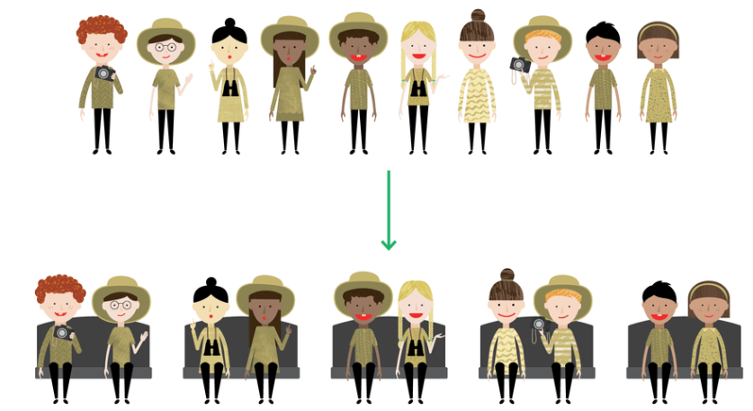  Or |  | See concrete |  | Represent using division statements
Dividing by 5  Grouping in groups of 5  20 divided in to groups of 5 is 4 groups.  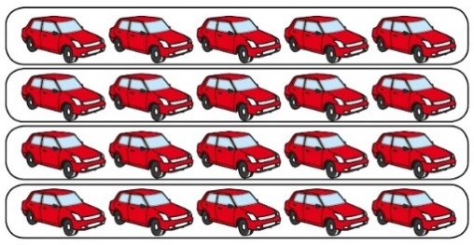  (Array)  Or  20 shared equally into 5 groups is 4 in each group |  | Represent pictorially. |  | Use known multiplication facts to support.  I know that 4 groups of 5 makes 20 so I know that 20 divided by 5 is 4.  4 × 5 = 20 so 20 ÷ 5 = 4  Use understanding of repeated addition to support dividing- shows links/relationship between multiplication  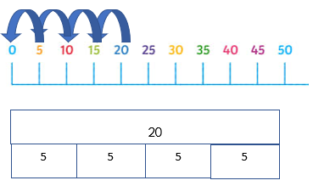
Dividing by 10
Follow methods in dividing by 5
Odd and even numbers  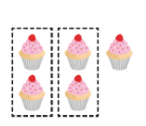  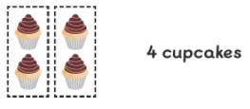  Children to recognise that even are divisible by 2 |  | children to recognise patterns of odd numbers. |  | Children to recognise odd and even numbers using known facts- 2 times table.
Conceptual Vairation: I have 24 cakes that I want to share between 2 people at a party. How many cakes will they get each?
Recall of division facts
24 ÷ 2= 12

Division
Key Language: | groups, equal, fair, unfair, unequal, odd, even, sharing, grouping, dividing, dividend, divisor, quotient, fact families, related facts, regrouping
Year 3
Year 3  - recall and use multiplication and division facts for the 3, 4 and 8 multiplication tables  - write and calculate mathematical statements for multiplication and division using the multiplication tables that they know, including for two-digit numbers times one-digit numbers, using mental and progressing to formal written methods  - solve problems, including missing number problems, involving multiplication and division, including positive integer scaling problems and correspondence problems in which n objects are connected to m objects. |  |  | Resources  - dienes  - plates  - counters  - multiplication grids  - number lines  - part whole models  - bar models
Concrete |  | Pictorial |  | Abstract
Dividing by 3  Sharing  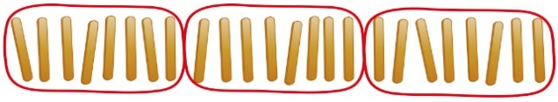  Or grouping |  | 24 ÷ 3 = 8  3 x 8 =24  Sharing  Grouping  24 ÷ 3 = 8  8 x 3 = 24  Represent using arrays |  | Using known facts  I know 3 x 8 = 24 so 24 ÷ 3 = 8.  I know 8 x 3 = 24 so 24 ÷ 8 = 3  c  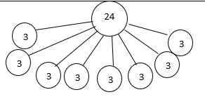  24  8  8  8
Dividing by 4
Follow similar concepts to dividing by 3
Dividing by 8
Follow similar concepts to dividing by 3
Simple dividing  Using dienes  6 tens divided by 2 is 3 tens.  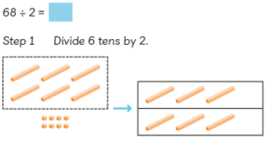  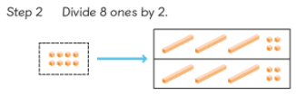  8 ones divided by 2 is 4 ones |  | Represent pictorially |  | Using known facts  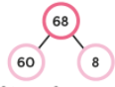  60 dividing by 2 = 30  8 divided by 2 = 4
Dividing with regrouping  Children to use known facts from the each times table to support them in recognising known multiples  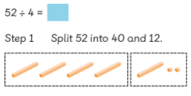  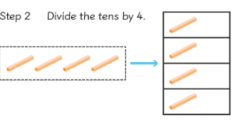  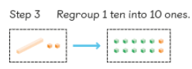  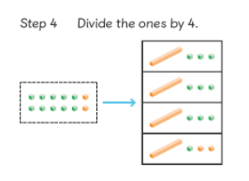 |  | Represent pictorially |  | Using known facts to support with partitioning the dividend.  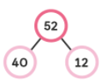  40 divided by 4 = 10  12 divided by 4 = 3  10 + 3 = 13  So  52 divided by 4 = 13
Conceptual Vairation: 68 people need to be placed on a ride. Each cart seats 4 people. How many carts are needed to fit everyone on the ride?
Parition 68 into 2 multples of 4 and divide  40 ÷ 4= 10  28 ÷ 4 = 7  10 + 7= 17    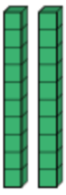 |  | Represent pictorially |  | 40 ÷ 4= 10  28 ÷ 4 = 7  10 + 7= 17

Division
Key Language: | groups, equal, fair, unfair, unequal, odd, even, sharing, grouping, dividing, dividend, divisor, quotient, fact families, related facts, remainders, long division, short division
Year 4
Year 4  - recall multiplication and division facts for multiplication tables up to 12 × 12  - use place value, known and derived facts to multiply and divide mentally, including: multiplying by 0 and 1; dividing by 1; multiplying together three numbers  - recognise and use factor pairs and commutativity in mental calculations  - multiply two-digit and three-digit numbers by a one-digit number using formal written layout  - solve problems involving multiplying and adding, including using the distributive law to multiply two digit numbers by one digit, integer scaling problems and harder correspondence problems such as n objects are connected to m objects. |  |  | Resources  - dienes  - counters  - place value counters  - number lines  - part whole models  - bar models  - bus stop models
Concrete |  | Pictorial |  | Abstract
Dividing by 6  Sharing  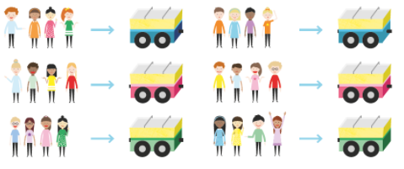  24 divided by 6 = 4  Or grouping |  | Represent pictorially |  | Use related facts to support understanding of dividing by 6  4 x 6 = 24 so 24 divided by 6 = 4  6 x 4 = 24 so 24 divided by 4 = 6  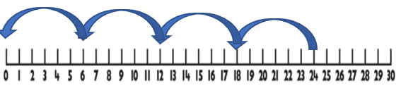  Or  24  4  4  4  4  4  4
Dividing by 7
Follow similar concepts to dividing by 3
Dividing 9
Follow similar concepts to dividing by 3
Dividing by 11 and 12
Follow similar concepts to dividing by 3
Dividing with a remainder  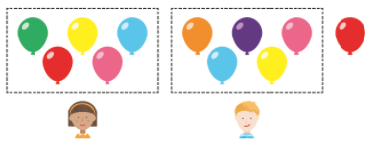  Divide ones then tens  29 divided by 2 = 14 remainder 1  Children to keep groups equal  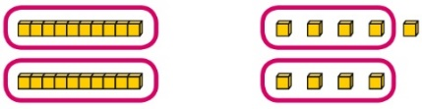 |  | Represent pictorially |  | Using known multiples and partitioning to divide  29  28  1  28 divided by 2 is 14- remainder one
Dividing by 1  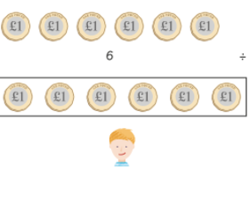 |  | Use pictorially |  | Stem sentence:  When the divisor is 1 the quotient and the dividend will always be the same.
Dividing 2 digit numbers  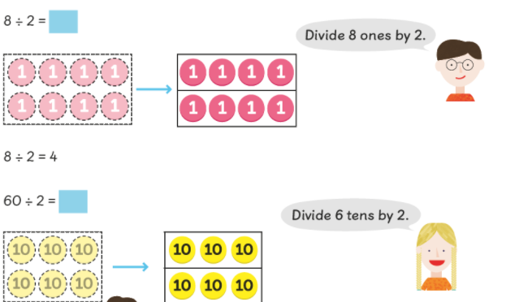  68= 60 + 8 |  | Represent pictorially. |  | 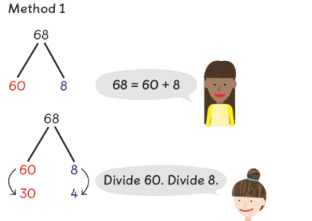  Or bus stop method  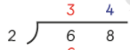  60 divided by 2 = 30  8 divided by 2= 4  30 + 4 = 34
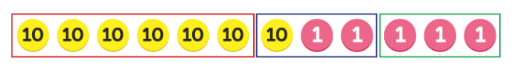  Dividing 2 digit numbers with remainders |  | Represent pictorially |  | 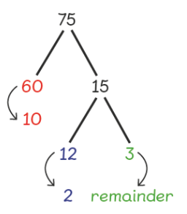  60 divided by 6 = 10  12 divided by 6 = 2  Remainder 3  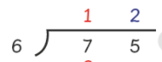  Remainder 3  1
Dividing 3 digit numbers  444 divided by 4 = 111  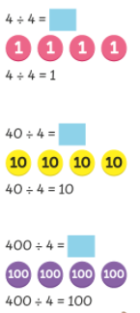 |  | Represent pictorially |  | 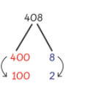  Partition into multiples of the divisor  Or bus stop method  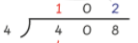
Dividing 3 digit numbers with remainders  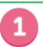  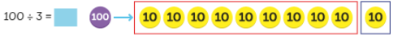  Remainder |  | Represent pictorially |  | Use known facts  100= 90 + 9 + 1  90 divided by 3= 30  9 divided by 3= 3  30 + 3 = 33 remainder 1  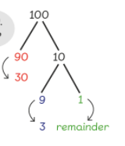  Or bus stop  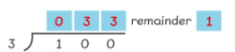  1
Conceptual Vairation: 49 sweets are shared between 4 friends. How many sweets are left over?
 |  | Represent pictorially  Remainder 1 |  | 1 2 r1  4 9
  12 | 12 | 12 | 12

Division
Key Language: | groups, equal, fair, unfair, unequal, odd, even, sharing, grouping, dividing, dividend, divisor, quotient, fact families, related facts, remainders
Year 5
Year 5  - divide numbers up to 4 digits by a two-digit whole number using the formal written method of long division, and interpret remainders as whole number remainders, fractions, or by rounding, as appropriate for the context ♣ divide numbers up to 4 digits by a two-digit number using the formal written method of short division where appropriate, interpreting remainders according to the contex |  |  | Resources  - place value grid  - part whole models  - bar models  - place value counters  - long division calculation frame  - multiplication grid
Concrete |  | Pictorial |  | Abstract
Dividing by 10, 100 and 1000  4000 divided by 1000    4000 divided by 100    4000 divided by 10  x 40 |  | Represent pictorially |  | Understand how and why the digits change on a place value grid when dividing by 10, 100 or 1,000.  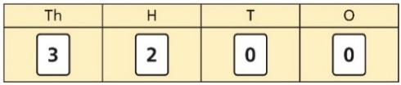  3,200 ÷ 100 = ?  3,200 is 3 thousands and 2 hundreds.  200 ÷ 100 = 2  3,000 ÷ 100 = 30  3,200 ÷ 100 = 32  So, the digits will move two places to the right.
Dividing 3 digit and 4 digit numbers  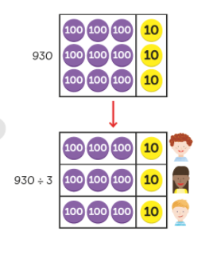 |  | Represent pictorially |  | 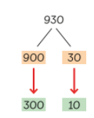  900 divided by 3 = 300  30 divided by 3 = 10  930 divided by 3 = 310  Or long division  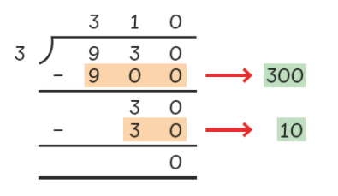
Dividing 4 digit numbers  2528 divided by 8= 316  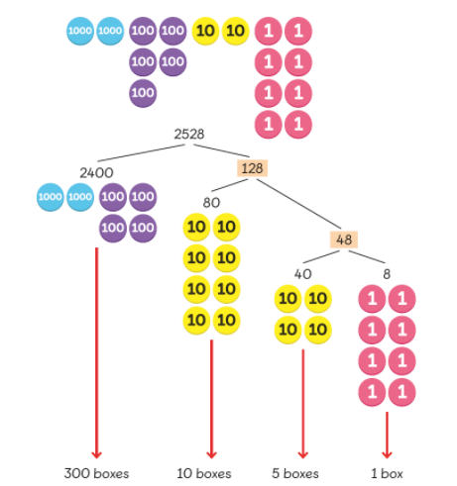  Find multiples of 8 |  | Represent pictorially |  | 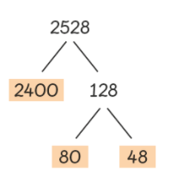  Known multiples  2400 divided by 8 = 300  80 divided by 8= 10  48 divided by 8= 6  300 + 10 + 6 = 316  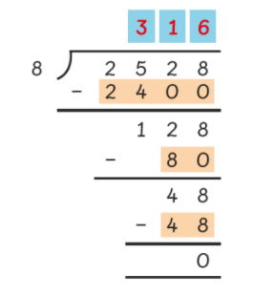  Long division
Dividing with remainders  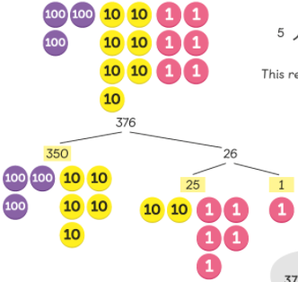  Finding multiples of the divisor (mental strategies)  350 divided by 5= 70  25 divided by 5 = 5  70 + 5= 75 Remainder 1 |  | Represent pictorially |  | Short division 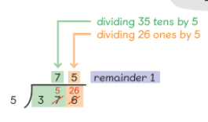
Dividing a fraction by a whole number  5 apples divided by 3  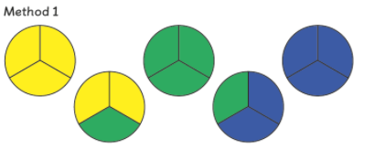  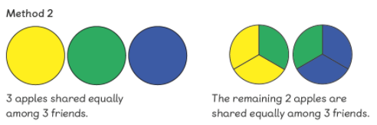 |  | Represent pictorially |  | 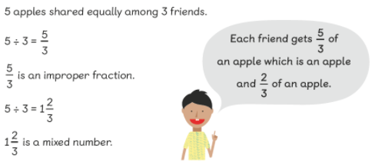
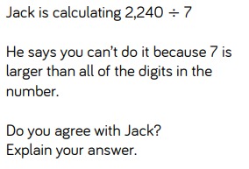
Conceptual Vairation:
2240  divided by 7 = 300  divided by 7= 20  300 + 20 = 320 |  | Represent pictorially |  | 0  2  1  3  2 2 4 0  7

Division
Key Language: | groups, equal, fair, unfair, unequal, odd, even, sharing, grouping, dividing, dividend, divisor, quotient, fact families, related facts, remainders
Year 6
Year 6  - divide numbers up to 4 digits by a two-digit whole number using the formal written method of long division, and interpret remainders as whole number remainders, fractions, or by rounding, as appropriate for the context  - divide numbers up to 4 digits by a two-digit number using the formal written method of short division where appropriate, interpreting remainders according to the context  - solve problems involving addition, subtraction, multiplication and division  - divide proper fractions by whole numbers [for example, 3 1 ÷ 2 = 6 1 ]  - associate a fraction with division and calculate decimal fraction equivalents [for example, 0.375] for a simple fraction [for example, 8 3 ]  - identify the value of each digit in numbers given to three decimal places and multiply and divide numbers by 10, 100 and 1000 giving answers up to three decimal place  - use written division methods in cases where the answer has up to two decimal places  - recall and use equivalences between simple fractions, decimals and percentages, including in different contexts. |  |  | Resources  - place value counters  - bar models  - place value grids  - part wholes  - dienes
Concrete |  | Pictorial |  | Abstract
dividing by 2 digit numbers  grouping:  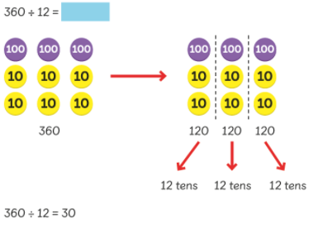 |  | Represent pictorially |  | 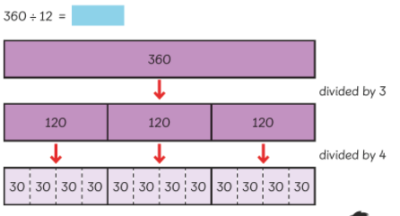  using bar models to partition the dividend in steps  Long division  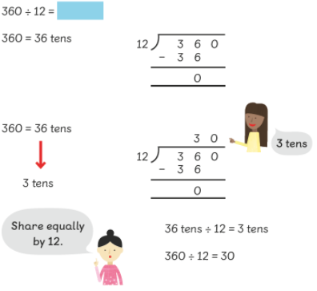  4 digit by 2 digit example:  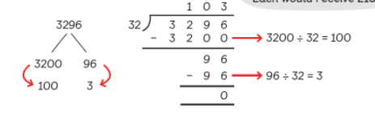  Short division  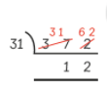
Dividing by 2 digit numbers with remainders  Use similar processes to dividing by 2 digit numbers |  |  |  | Partitioning  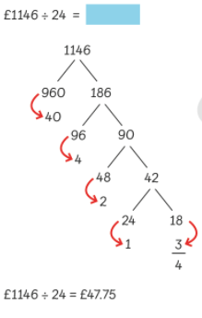  Long division  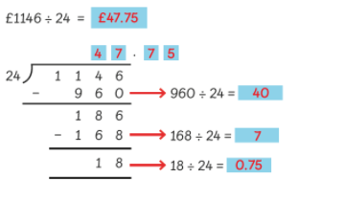
Finding common factors  Understand that division by factors can be used when dividing by a number that is not prime.  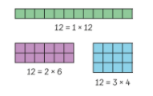 |  | Represent pictorially |  | 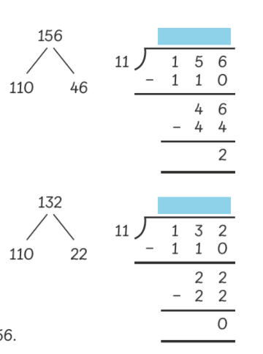  knowing that in order to find a factor of a number it must be able to divide equally by that number
Dividing a fraction by a whole number  show the fraction using a bar a divide by the divisor:  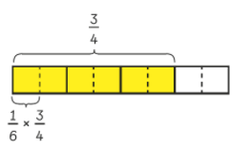  ¾ divided by 6 |  |  |  | 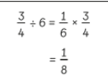  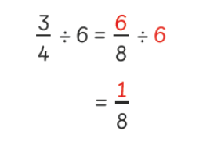
Dividing whole numbers 10, 100 and 1000 up to three decimal places  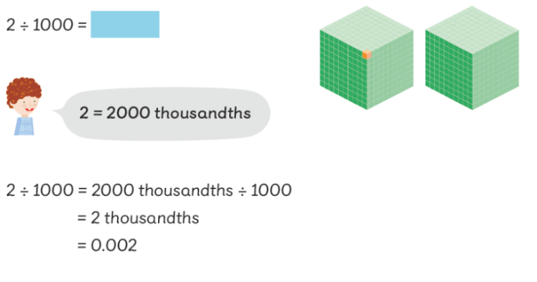  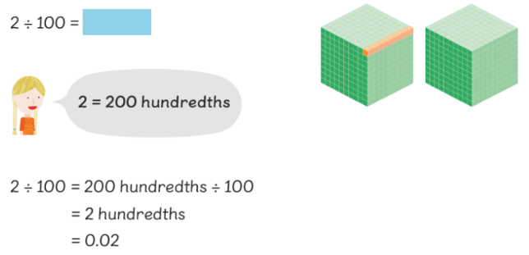  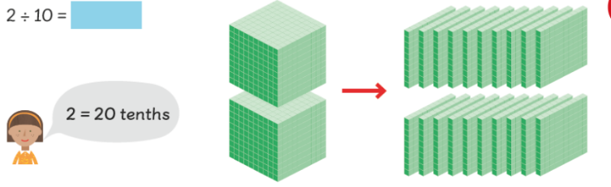 |  | Represent pictorially |  | 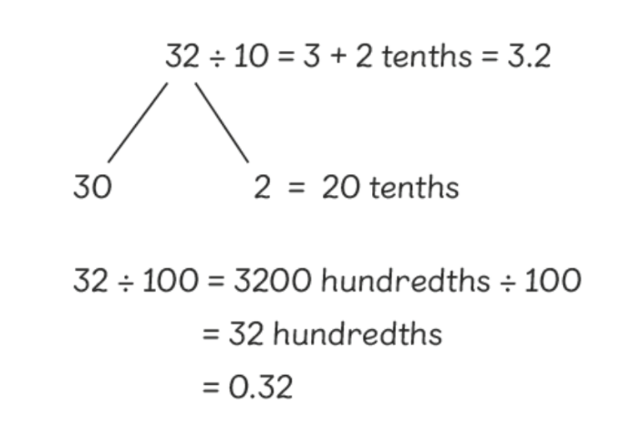  partition the dividend
Dividing whole numbers  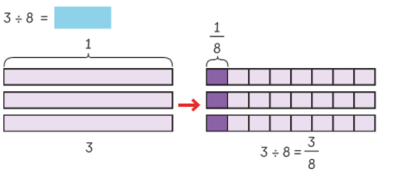 |  |  |  | Understanding the relationship between how much each part is worth when dividing 100 (seeing 100 as 1 whole)  e.g 100 divided by 8= 12.5 so 1 divided by 8= 0.125  3/8 is 0.125 x 3 = 0.375  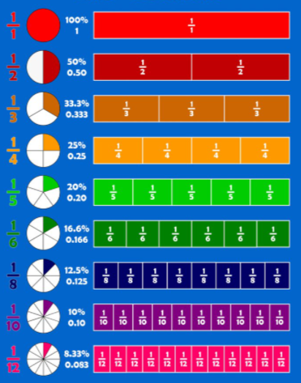
Dividing decimals     |  | Represent pictorially |  | 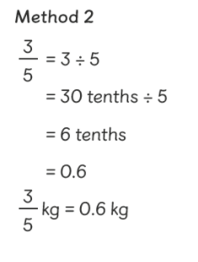
Dividing decimals  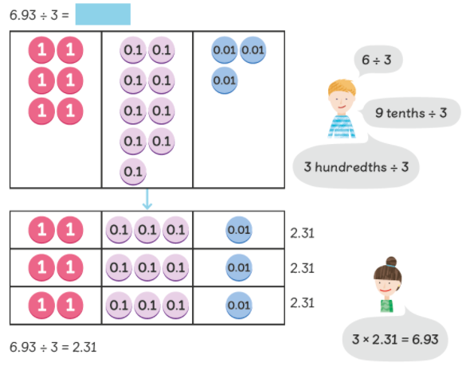 |  | Represent pictorially |  | 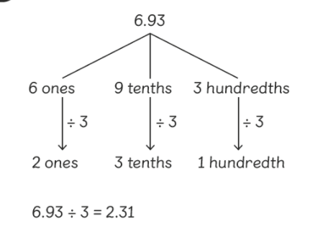
Dividing decimals by a 2 digit number  8.4 divided by 12  1ten= 0.1  6 divide by 12  (repeat process to show that 6 divided by 12 = 0.5)  2.4 divided by 12 |  | Represent pictorially |  | 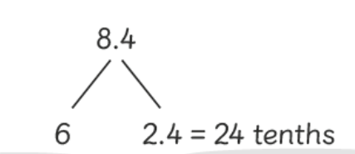
Finding the percentage of a number  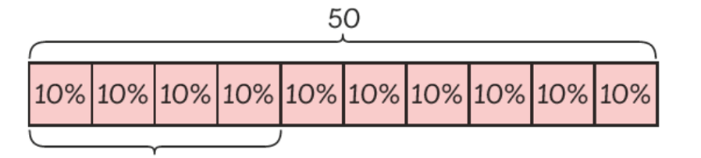 |  | Represent pictorially |  | 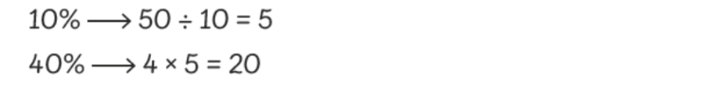
Finding percentage of a quantity  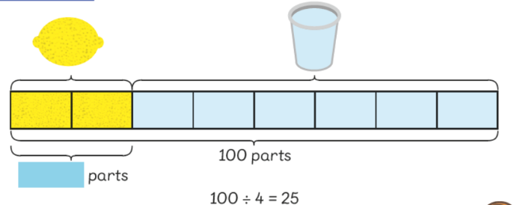 |  |  |  | 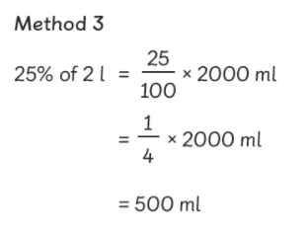
Finding percentage of change  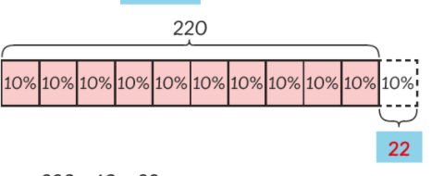 |  | Represent pictorially |  | 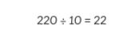
Conceptual Vairation: 3.96 ÷ 3
 |  | Represent pictorially |  | 3.96 ÷ 3=  3 ÷ 3 = 1  0.9 ÷ 3= 0.3  0.06÷ 3= 0.02  1 + 0.3 + 0.02 = 1.32

