

Mathematics Calculation Policy

Subtraction
Key Language: | Subtract, take away, less, smaller, part, whole, less than, number line, number track
Reception
ELG  - Automatically recall (without reference to rhymes, counting or other aides) number bonds up to 5 (including subtraction facts) and some number bonds to 10, including double facts. |  |  | Resources  - Objects for counting  - Fives/tens frames  - Picture cards-different representations of number  - Number line/track
Concrete |  | Pictorial |  | Abstract
Find one less than a given number between 10  Count the whole and then take away one at a time to show that the number is becoming one less than it was.   |  | Use a five frame to show a given number.  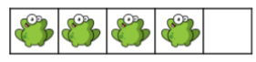  Remove one object/counter to show the number becoming one less than the number before.  Use the number line to consolidate understanding of the number getting smaller. |  | 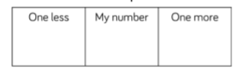  Children to use a number line to show one step back means one less.
Introducing 0  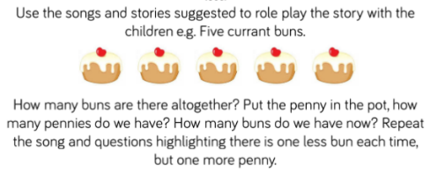 |  | Children to see objects being taken away to show nothing- what is the number that is left over?   |  |   Children to represent the number 0 using different representations and make the correspondence to the number.
Taking away by counting back  Children to count out a set of objects. Then children should take away an amount from the whole they counted.   |  | 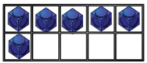  Use tens frames to represent taking away objects. |  | Get children to start at the biggest number and count back/jump back using a counter.  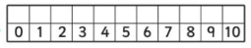
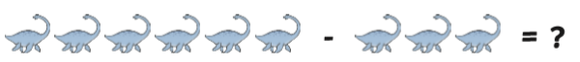
Conceptual variation:
Children to remove the amount of dinsoaurs that they have been asked to take away from the whole. |  | Children to use a tens frame to create the whole and then remove the part to show the final part.  Children to remove three counters then recount the coutners remaing on the tens frame to show the answer. |  | Children to start from the biggest number and make jumps back depending on how many they are taking away. Children to use a counter to help them when coutning each number back.

Subtraction
Key Language: | take away, less than, the difference, subtract, minus, fewer, decrease,
Year 1
National curriculum  - read, write and interpret mathematical statements involving addition (+), subtraction (–) and equals (=) signs  - represent and use number bonds and related subtraction facts within 20  - add and subtract one-digit and two-digit numbers to 20, including zero  - solve one-step problems that involve addition and subtraction, using concrete objects and pictorial representations, and missing number problems such as 7 = – 9. |  |  | Resources  - objects for counting  - Part whole models  - Tens frames  - Number tracks/ number lines  - Multilink
Concrete |  | Pictorial |  | Abstract
Subtract by crossing out  Children to replicate crossing out with concrete resources by removing them from the whole.  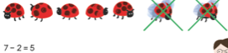 |  | children to draw pictures to represent the number sentence and then show they are taking away by crossing out.
Subtract using number bonds  Whole- part = part  Partition whole into two separate parts  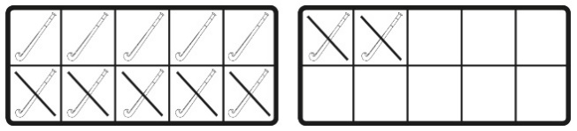  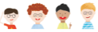  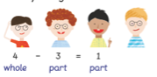 |  | Represent the concrete resources through drawing part whole models |  | 3 + 1 = 4  1 + 3 = 4  4  3  1  4 – 3 = 1  4 – 1 = 3  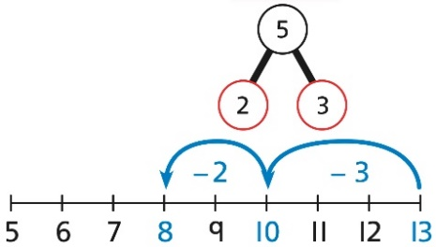
Subtract by counting back  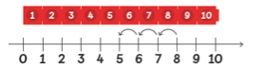 |  |  |  | Children to count back mentally without the need for a number line.
Subtracting ones  Group the objects into one ten and ones. Then take away from the tens.  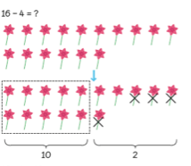  Represent using a tens frame |  | Represent previous representation using pictures. |  | Partition the whole and then take away the ones separately.  16  10  6  6 – 4 = 2  2 + 10 = 12
   |  | X | X | X
  X
Subtracting from 10 when there are less ones  Partition 14 into 10 and 4. Children should realise that they cannot take away the ones as there are too many. They should then take away from the tens.  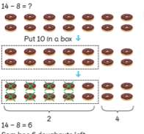  Use tens frames to partition the number into tens and ones. Then take away from the tens. |  | Represent previous representation using pictures. |  | 14  10  4  10 – 8 = 2  2 + 4 = 6
   |  | x | x | x
  x | x | x | x | x
Conceptual variation: 17 – 9 =
 |  | use tens frames pictorially |  | 17  10  7  10 – 9 = 1  1 + 7 = 8
   | x | x | x | x
  x | x | x | x | x

Subtraction
Key Language: | part, whole, tens, ones, exchanging, smaller, exchanging, subtracting, taking away, minus, difference
Year 2
National Curriculum  solve problems with addition and subtraction:  - using concrete objects and pictorial representations, including those involving numbers, quantities and measures  - applying their increasing knowledge of mental and written methods  - recall and use addition and subtraction facts to 20 fluently, and derive and use related facts up to 100  - add and subtract numbers using concrete objects, pictorial representations, and mentally, including:  a two-digit number and ones  a two-digit number and tens  two two-digit numbers  adding three one-digit numbers  - show that addition of two numbers can be done in any order (commutative) and subtraction of one number from another cannot  - recognise and use the inverse relationship between addition and subtraction and use this to check calculations and solve missing number problems. |  |  |  | Resources  - Dienes  - Place value grids  - Part whole models  - Number lines/tracks  - Counters  - Calculation frames (support with column subtraction)
Concrete |  | Pictorial |  |  | Abstract
Subtracting ones from a 2 digit number  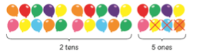  set the layout of the objects that they are counting as a tens frame.  Use place value grids to partition the number into tens and ones. Children cross out the ones they are subtracting.  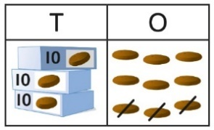 |  | 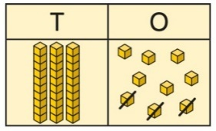  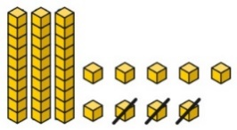  use dienes to represent the whole and then show that they have taken away by crossing out the ones.  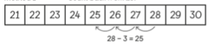  Children could draw number tracks/lines to show that they started at the whole and counted back in steps of one. Children should notice that when you are not exchanging, the only part of a number to change when taking away ones is the ones column. |  |  | 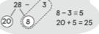  Children can partition the whole into tens and ones. Then children will take away the ones from one another and add the tens back on.  Children should be introduced to column subtraction however this should not be a method that they rely on when subtracting a one digit number from a two digit number without exchanging.  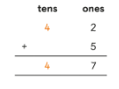
Subtracting tens from a 2 digit number  Make links from subtracting ones to subtracting tens.  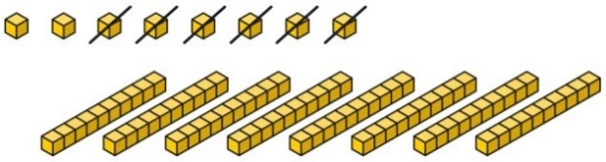  8 subtract 6 is 2.  So, 8 tens subtract 6 tens is 2 tens. |  | Number tracks- counting back in steps of ten. Understanding that the tens column reduces by 1 ten when you count back in steps of ten. |  |  | Partition the whole into tens and ones. Take away the multiple of ten from the tens in the whole. Then add the ones back onto the tens.  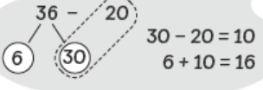  Use column subtraction as you did previously (to introduce it as a method to use), but do not allow children to become reliant on this method as these calculations should be done mentally.  3 6  - 2 0  1 6
  T | O
  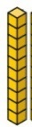 | 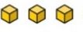
  13 | 23 | 33
Subtract a 2 digit number from a 2 digit number (column subtraction)  Children to use place value grids and dienes blocks to represent the calculation. Children to remove the dienes that they need to take away from the whole. |  | 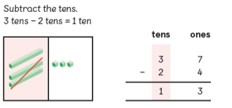  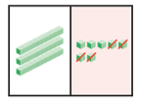  Use place value grids to set out the whole. Children should then remove the ones and then the tens. Children to remember that it is 30 -20 not 3 – 2. |  |  | Use column addition- children should recognise that this is trickier to do mentally but can still be done if partitioned.  Children should start from the ones and then move to the tens once they have subtracted the ones from each other.  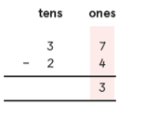
  T | O
   | 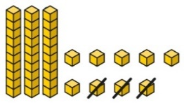
Subtracting from Multiples of 10  Using tens frames to support creating connections to subtraction from multiples of ten and number bonds to ten. |  | See concrete |  |  | 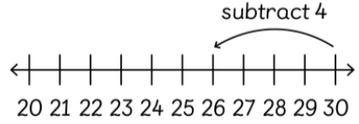  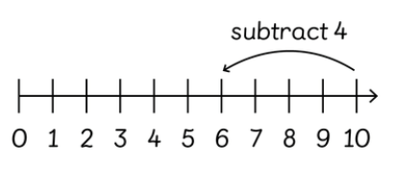  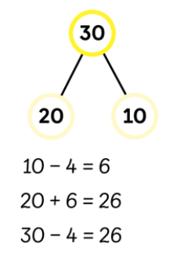
Subtracting with exchanging  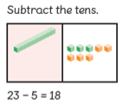  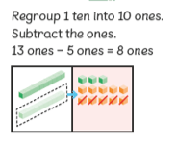  Use dienes and place value grids to represent the whole. Children to understand that they cannot take a bigger number away from a smaller number. |  | Represent the concrete representation pictorially |  |  | Use column subtraction with exchanging.  Ensure that children understand that they are moving 1 ten which becomes 10 ones that they add on to the ones there.  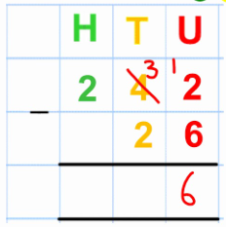  Children may be able to articulate their exchanging mentally using partition methods where 10 is already exchanged from the previous column:  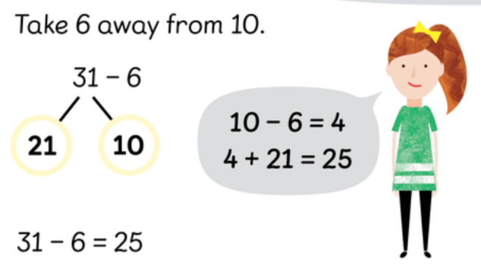
Conceptual Variation: Find the difference between 72 and 39
 |  |  | Represent dienes work pictorially. |  |  | 6  1  72  39  3 3  Use column subtraction
  T | O
   | 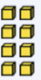
Subtraction
Key Language: | part, whole, thousand, hundreds, tens, ones, exchanging, smaller, exchanging, subtracting, taking away, minus, difference
Year 3
National Curriculum  Pupils should be taught to:  - add and subtract numbers mentally, including:  a three-digit number and ones  a three-digit number and tens  a three-digit number and hundreds  - add and subtract numbers with up to three digits, using formal written methods of columnar addition and subtraction  - estimate the answer to a calculation and use inverse operations to check answers  - solve problems, including missing number problems, using number facts, place value, and more complex addition and subtraction. |  |  |  | Resources  - Dienes  - Place value grids  - Part whole models  - Bar models
Concrete |  | Pictorial |  |  | Abstract
Subtracting ones from a 3 digit number  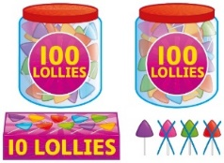  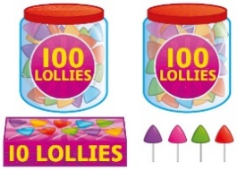  214- 3 =  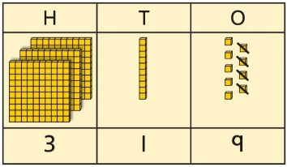  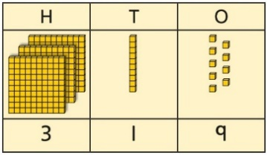  4 – 3 = 1  Using dienes to represent a number then removing the ones. |  | Represent using dienes blocks in previous column pictorially.  Using number tracks to count backwards. Recognising that the only part of the number that is changing is the ones column.  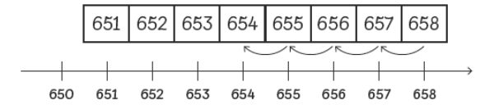 |  |  | 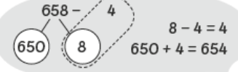  Partition the number into hundreds and tens-separating the ones. Take away the ones and then add the tens and ones back on.
Subtracting multiples of ten from a 3 digit number  Create the whole. Take away tens from the tens column. This can be put into a place value grid.  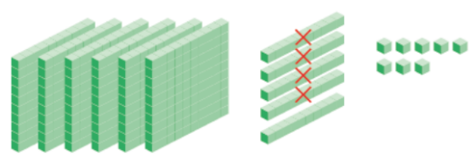 |  | Represent dienes in place value grid from previous column.  Use number tracks. Children should start at the whole and count back in steps of ten. Children should recognise that the only column to change at this point is the tens column. |  |  | 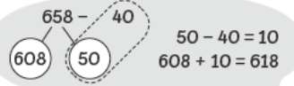  Children should partition the number into hundreds and ones and tens. Children should take away from the tens that have been partitioned
  618 | 628 | 638 | 648 | 658
Subtracting hundreds from a 3 digit number  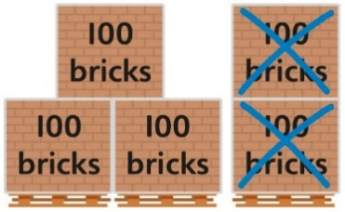  Physically show that part of the hundreds have been subtracted by removing them from the objects. |  | Draw previous representations pictorially using place a value grid. Children should cross out the hundreds that they are taking away.  Use number tracks. Children to count back in steps of 100 and recognise that the hundreds column is decreasing by one hundred each jump. |  |  | 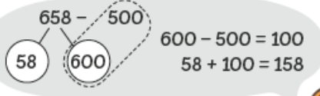  Partition the 3 digit number in to hundreds and tens and ones. Children should isolate the hundreds and take away the hundreds needed. Children should then add on the tens and ones.
  H | T | O
  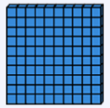
  128 | 228 | 328
Subtracting 3-digit number from a 3-digit number without exchanging (column addition)  Represent the whole using dienes and take away ones, tens then hundreds from the whole.  Children to show that they have taken away by physically removing the dienes needed. |  | 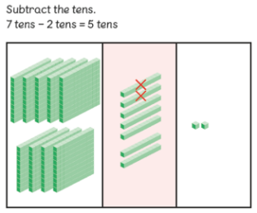  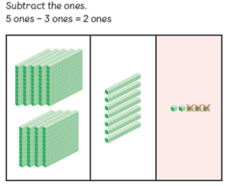  Use a dienes within a place value grid to represent the two numbers within the subtraction calculation. Children should use their knowledge from column addition to remember that they should start with the ones column.  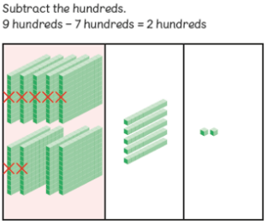 |  |  | 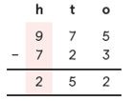  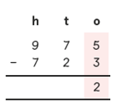  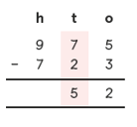  Use column addition to represent the previous model.
Subtracting with exchanging tens  Explore with dienes what 10 ones are equal to.  Children to think about how they could use this knowledge to help them when exchanging.  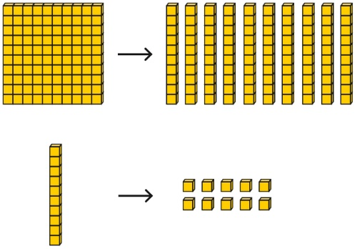 |  | Children to use their understanding of place value to exchange numbers when unable to subtract. 1 one – 5 ones cannot be done so children should exchange one ten as ten ones and move to the ones column. Children should understand that the ten hasn’t been taken away therefore the number is still 821.  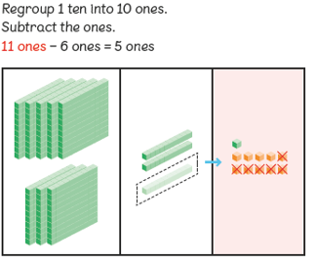  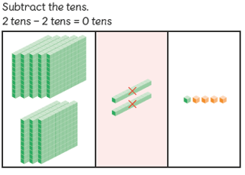  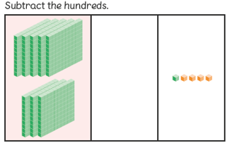 |  |  | 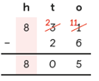  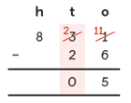  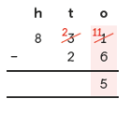  Use column addition and show where exchanging is taking place. Children should cross out the tens and show that they are moving it to the ones column as 10 ones .
Subtracting with exchanging hundreds  Explore using dienes what 10 tens are equal to. Children should use this information to support them when exchanging. |  | 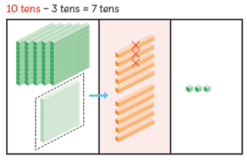  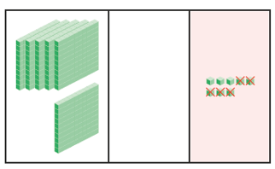  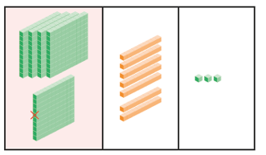 |  |  | Column subtraction showing exchanging.  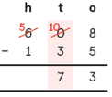  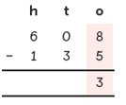  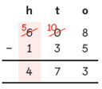  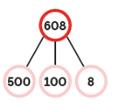  Partition the whole to ensure that the 100’s have been exchanged as the tens.  8- 5 = 3  100 – 30 = 70  500 – 100 = 400  400 + 70 + 8 = 478
Subtraction using models  Children to recognise the par-whole relationship within bar models  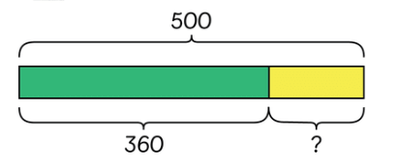 |  | See concrete represetion- to represent pictorially |  |  | 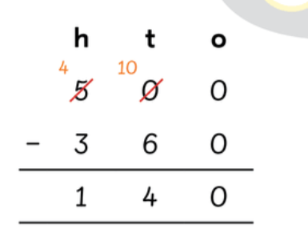  using a method that children find most efficient- column, partitioning.
Conceptual Variation: 438 - 176
1
3
Represent using dienes blocks in a place value grid |  |  |  |  |  | 438  176  262  438  8  130  300  8 - 6 = 2  130 – 70 = 60  300 – 100 = 200  200+ 60 + 2 = 262
  H | T | O

Subtraction
Key Language: | part, whole, thousand, hundreds, tens, ones, exchanging, smaller, subtracting, taking away, minus, difference
Year 4
National Curriculum  - add and subtract numbers with up to 4 digits using the formal written methods of columnar addition and subtraction where appropriate  - estimate and use inverse operations to check answers to a calculation  - solve addition and subtraction two-step problems in contexts, deciding which operations and methods to use and why. |  |  |  | Resources  - dienes  - Place value grids  - Part whole models  - Bar models
Concrete |  | Pictorial |  |  | Abstract
Finding Differences  Children to recognise the language ‘difference’ thinking about the link to subtraction:  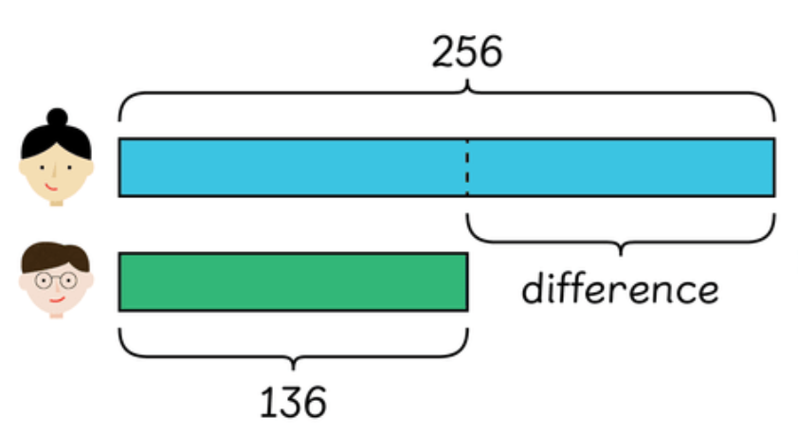  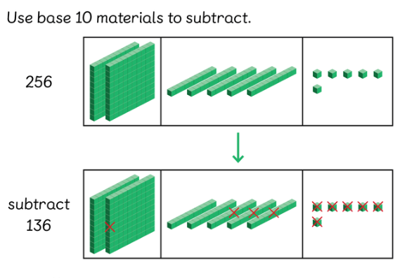 |  | See concrete |  |  | 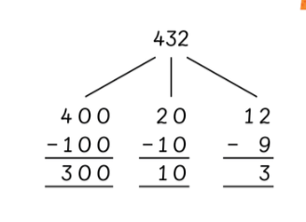  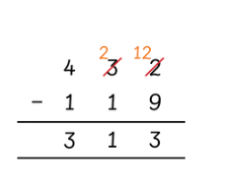
Subtracting with exchanging  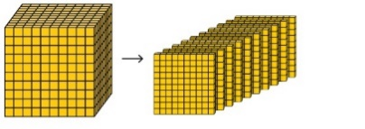  Spend time understanding the exchanging process and what happens when you exchange from one column to another  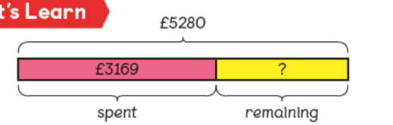  Use bar models to allow children to see that they are subtracting as they are finding part of the whole.  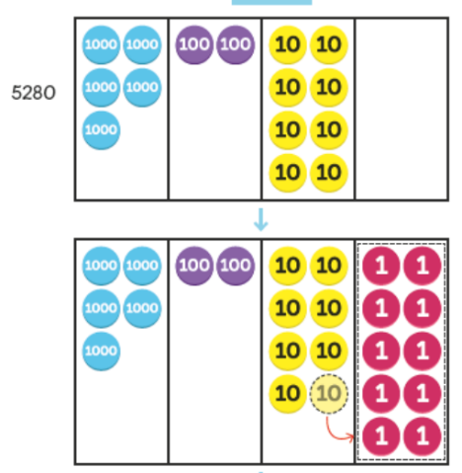  Use place value counters and dienes blocks to allow children to see that they cannot take away from certain columns and will therefore have to exchange. Children can then start to move tens to make ones etc. children then subtract from each column.  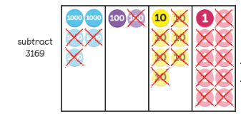 |  | Represent the use of the place value grid and counters in previous column pictorially. |  |  | Use column subtraction to show that they are taking from one column and exchanging the amount taken in another column in order to subtract each column one at a time.  Children need to show their understanding for place value here understanding that one hundred is the same as 10 tens etc.  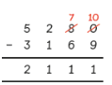  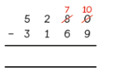  Children could also partition the number ensuring that they are able to subtract from each column.  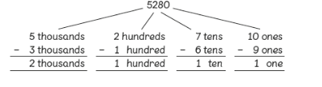
Subtracting using mental strategies  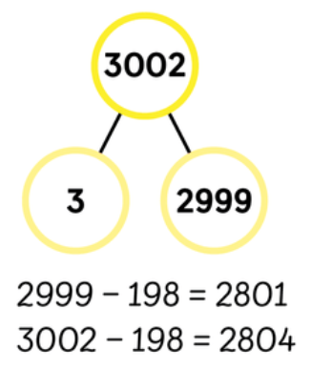  Children to recognise that they can partition wholes to allow them to subtract mentally. Children can use dienes to support this. |  | See concrete |  |  | Children to be able to partition mentally to support them in subtracting.
Conceptual variation: find the difference between 6001 and 2345
 |  |  | Represent pictorially using place value grids and place value counters. |  |  | 6001  11  9  9  5  2345  3656  Or  6001  5999 2  5999-2345= 3654  3654 + 2 = 3656
  Th | H | T | O

Subtraction
Key Language: | part, whole, millions, hundreds of thousands, tens of thousands, thousand, hundreds, tens, ones, smaller, exchanging, subtracting, taking away, minus, difference
Year 5
National Curriculum  -add and subtract whole numbers with more than 4 digits, including using formal written methods (columnar addition and subtraction)  -add and subtract numbers mentally with increasingly large numbers  -use rounding to check answers to calculations and determine, in the context of a problem, levels of accuracy  -solve addition and subtraction multi-step problems in contexts, deciding which operations and methods to use and why |  |  | Resources  - Place value counters  - Place value grids  - Decimal counters  - Number tracks
Concrete |  | Pictorial |  | Abstract
Counting Backwards to Subtract  Use place value counters to support children visually with counting backwards. Exchange where appropriate using counters.  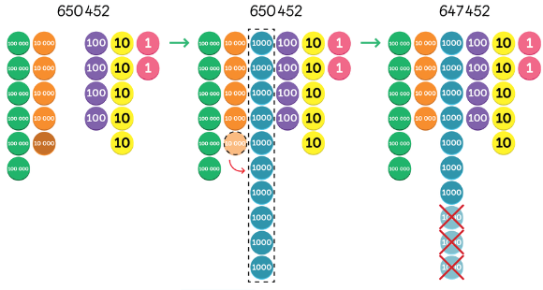 |  | See concrete and represent pictorially |  | 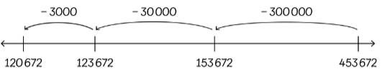  Partition the part within the sentence and subtrat each place value column from the number in steps.
Subtracting within a million  Show that they have taken away by removing the counters/crossing out.  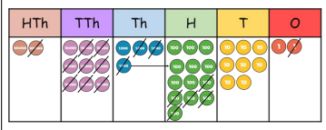 |  | Represent previous representation pictorially |  | Column subtraction- ensure columns are arranged correctly.  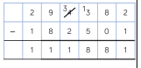
Subtracting decimals  Use place value counters to create decimals and then take away by removing the counters.  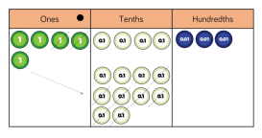 |  | Use number tracks to support counting backwards/crossing out when subtracting. |  | Column subtraction  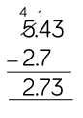

Subtraction
Key Language: | part, whole, millions, hundreds of thousands, tens of thousands, thousand, hundreds, tens, ones, exchanging, smaller, exchanging, subtracting, taking away, minus, difference
Year 6
National Curriculum  - solve addition and subtraction multi-step problems in contexts, deciding which operations and methods to use and why |  |  | Resources  - place value counters  - Place value grids  - Decimal counters
Concrete |  | Pictorial |  | Abstract
Master previous methods

