Battling Brook Pre-School are now accepting applications for September 2027

Ready - Respectful - Safe

Building Relationships
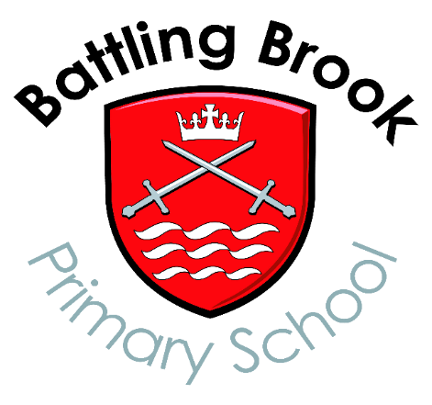
Community Environment

Nurturing
Teamwork
Forest School

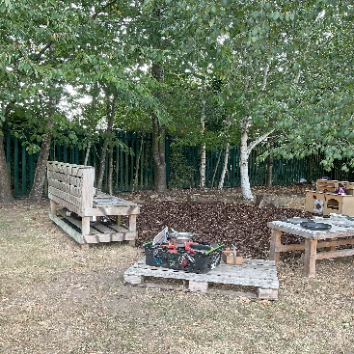
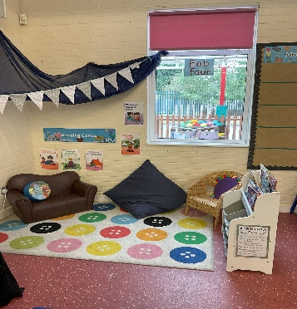
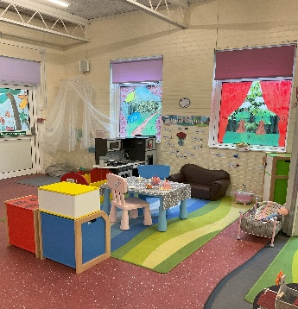

If you would like more information or wish to come and view our amazing facilities, please call the school office on 01455 634701 or email office@battlingbrook.uk

‘Equality, Active learning, Community, Health & Happiness’

