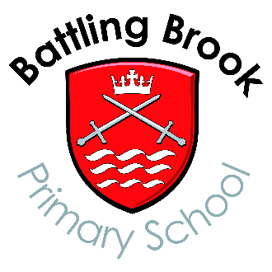
Frederick Avenue
Hinckley
Leics.
LE10 0EX
Tel. 01455 634701
Fax. 01455 890674
Headteacher
Mrs L Mathie.
B.A. (Q.T.S
N.P.Q.H
NASENCo

Application form for community governors

Battling Brook Primary School

To be completed by the candidate (please print)

I wish to apply to be a governor of the above school.

Please note that the school is required to carry out an enhanced Disclosure & Barring Service (DBS) check on the successful candidate.

Name:

Address:

Daytime telephone number:

Email:

Signature:

Candidate's personal Statement (no more than 250 words)

Please email your application to clerk@battlingbrook.uk – labelled School Governor Application.

